**Project Specification**

**Project Name: CHESS-1**

**Test Chip: CMOS (HV/HR) Evaluation for Strip Sensors-1**

**Version: V 0.7**

***Abstract***

This document lists the target specifications for the test chip, which will be fabricated and tested in order to evaluate the basic device performance of HV/HR-CMOS technologies for use as a silicon strip sensor. Two representative foundries will be used.

|  |  |  |
| --- | --- | --- |
| ***Prepared by:*** | ***Checked by:*** | ***Approved by:*** |

|  |  |  |  |
| --- | --- | --- | --- |
| ***Revision History*** | | | |
| ***Rev. No.*** | ***Date*** | ***Pages*** | ***Description of Changes*** |
| 0.0 | 2014/05/21 |  | Initial draft |
| 0.1 | 2014/05/22 |  |  |
| 0.2 | 2014/06/08 |  | Changed pixel width to 40 um.  Changed diode area fraction for the 2 technologies.  Added passive diode arrays with dummy transistors/amplifier for HV-CMOS.  Added large area array for CCE measurements.  Changed “fast amplifier” specs. |
| 0.3 | 2014/06/16 |  | A few typographical errors corrected.  The remaining open issues inserted into the spec in red |
| 0.4 | 2014/06/17 |  | Add drawing of proposed pad layout.  Added titles for a few more needed tables, but table information yet to be included. |
| 0.5 | 2014/06/20 |  | Figures for pad layouts in Sections 3.1 and 3.3 are corrected. Shorter end pixels for arrays with pixel lengths > 400 m. A trial chip layout added in Figure 4.1. A few more details resolved. A few still unresolved in red. Questions from Ivan, Daniel & Alex inserted in green. |
| 0.6 | 2014/07/21 |  | Incorporated several comments from Renato & Ivan. Included pad sizes for all structures and a description of pad layout for the array of single components in 3.6 along with pad layout diagrams. Added list of single components arrayed in 3.6. Added a best estimate chip floor plan and size. Unfinished details highlighted in green. |
| 0.7 | 2014/08/05 |  | Added extra variations to the list of passive active pixel arrays. Changed the width of HV-CMOS pixels to 45 m and the largest diode area fraction to 50.4% to work with AMS design rules. |

**Table of Contents**

# 1 SCOPE

This document describes the details of the target specification for a test chip, which will be fabricated in order to evaluate the basic device properties of HV-CMOS and HR-CMOS technologies for use as silicon strip sensors in place of the traditional planar silicon strip sensors. The test chip will be made up of several different types of test structures, each designed to test certain characteristics of the technologies. For each type of test structure, several variations of device features will be included, for example variations in the length and fill factor of the individual pixel areas. The expectation is that two foundries will be sampled and some technology specific differences will be made to the designs to match the requirements of each foundry’s technology.

# 2 Foundries

Two foundries will be targeted at this time based upon the current understanding of the available technologies and their appropriateness for strip sensors. The two technologies are Tower-Jazz TJ180 and Austrian Micro Systems AMS-H35.

# 3 Test Structure Types and Their Specifications

The test chip will be comprised of six different types of test structures. Each is described below along with their specifications and variations. A question has been raised whether a guard ring is needed around each pixel array. Given that each pixel is surrounded by a ring of contacts to the substrate, it is not clear what purpose such guard ring would serve. Unless objections are raised, no guard rings will be included.

## 3.1 Passive Pixel Arrays

For HV-CMOS technology, there will be groups of 3 x 3 pixels arranged in a rectangular array such that the eight outer pixels are electrically tied together and connected to a single probe pad. The inner pixel will be connected to a separate probe pad. An example is shown in Figure 3.1.1. This will allow direct measurements of the charge collection characteristics and pixel capacitance independent of any built-in amplifier circuitry. The metal size of the two probe pads for contact to the substrate and the perimeter ring of pixels will be 45 m x 90 m with glass openings of 35 m x 80 m. The probe pad for the center pixel signal contact will have a glass opening of 30 m x 30 m and a metal size of 40 m x 40 m, except that the size of the metal pad may be reduced if the design rules allow less than a 5 m glass overlap at the pad edge. We expect to apply pixel bias through the same probe pads as used to measure capacitance. About 40% of the top pixel surface should have no metallization to allow laser injection measurements. Two extra passive pixel arrays will be included in the two upper corners of the floor plan (See figure 4.1.) to facilitate E-TCT tests. These will be 3x3 arrays of 45 m x100 m size and 30% diode area fraction. All three pad openings will be 35 m x 80 m and placed along the short edge of the array to facilitate wire bonding for these tests. Some arrays will be made with “dummy” disconnected transistors and amplifiers to evaluate their effect on the pixel capacitance. Extra pads will be needed for these arrays to bias the transistors and amplifiers. They will sit outside the array area shown in Figure 3.1.1. Also, one array size will have variations in the type and location of contact rings to the substrate.

Table 3.1.1 lists the various pixel sizes that will be used in each HV-CMOS array. For cases where the pixel length exceed 400 m, the outer column of three pixels on the left and right of Figure 3.1.1 will be held to a length of 400 m in order that the total length of the structure not be excessively long.

**Figure 3.1.1: Layout for Smallest Passive Pixel Array in HV-CMOS Technology**

**Relative positions of two top probe pads (for Perimeter Pixels and the Substrate) will increase for larger pixels. The 40 m x 40 m metal pad may be reduced in size. See the text above.**

The HR-CMOS technology will feature much smaller diode area fractions and will need extra voltage buffers to evaluate the (smaller) capacitance. The array would be larger, about 16x16 pixels to avoid stray effects. No variation of diode area fraction is foreseen. Each pixel will contain a source-follower with row and column lines attached for scanning the pixels as in an imaging array. A copy of the source follower will be included in the array of transistors (See section 3.6.) so that its contribution to the pixel capacitance can be measured.

The pad layout for this 16 x 16 array will form a rectangular ring around the array as 20-30 pads will be required.

**Figure 3.1.2: Pad Layout for Each “Passive Array” in HR-CMOS Technology**

{Renato to provide. }

### 3.1.1 Passive Pixel Array Specifications

The passive pixel arrays will have the following specifications. For each set of specifications, 1 array will be included. In most cases the diode area will actually be made of several individual diodes arrayed along the length of the pixel tied together by a metal line.

**Table 3.1.1.A: Passive Pixel Array Spatial Specifications for HV-CMOS Technology**

|  |  |  |  |
| --- | --- | --- | --- |
| PPA # | Pixel Dimensions | Diode Area Fraction | Extra circuitry |
| PPA01 | 45 m x 100 m | 30% |  |
| PPA02 | 45 m x 100 m | 50.4% |  |
| PPA03 | 45 m x 200 m | 30% |  |
| PPA04 | 45 m x 200 m | 50.4% |  |
| PPA05 | 45 m x 400 m | 30% |  |
| PPA06 | 45 m x 400 m | 50.4% |  |
| PPA07 | 45 m x 800 m | 30% |  |
| PPA08 | 45 m x 800 m | 50.4% |  |
| PPA09 | 45 m x 200 m | 50.4% | Disconnected transistors |
| PPA10 | 45 m x 200 m | 50.4% | Disconnected amplifier |
| PPA11 | 45 m x 100 m | 30% | Special bond pads for E-TCT |
| PPA12 | 45 m x 100 m | 50.4% | Special bond pads for E-TCT |
| PPA13 | 45 m x 200 m | 30% | Without contact ring around each pixel, but with contact ring around the entire array having a separate pad |
| PPA14 | 45 m x 200 m | 30% | With contact ring around each pixel that violates the design rules by having a symmetric width |
| PPA15 | 45 m x 200 m | 30% | With contact ring around each pixel that meets the design rules and a contact ring around the entire array having a separate pad |

The disconnected amplifier will be biased with its input tied to ground. The pixel array with a few disconnected transistors will have the transistors biased.

**Table 3.1.1.B: Passive Pixel Array Spatial Specifications for HR-CMOS technology**

|  |  |  |
| --- | --- | --- |
| PPA # | Pixel Dimensions | Diode Area Fraction |
| PPA01 | 40 m x 100 m | Few % |
| PPA02 | 40 m x 200 m | Few % |

{Renato to confirm these pixel sizes.}

**Table 3.1.2: Assignment of pads for “Passive” Pixel Arrays in HR-CMOS Technology.**

{This table can be filled in later as long as there is a figure 3.1.2 with pad layout.}

## 3.2 Large Passive Array

To facilitate charge collection measurements with a source one would need a structure with relatively large area. To that effect, a 2x2 mm^2 area should be implemented as a passive diode array with common output from all pixels. The pixel size to be used is 45 m x 200 m, with a diode area fractional of 40%. The signal pad and the biasing pads will have metal dimensions of 90 m x 100 m with glass openings of 80 m x 90 m placed in a convenient location.

## 3.3 Active Pixel Arrays

There will be groups of 5 x 5 pixels arranged in a rectangular array. Each pixel will include a fast amplifier circuit, which may not be representative of the amplifiers to be used in the actual CMOS strip sensors but is very fast to allow evaluation of the time structure of the collected charge. The power consumption of this amplifier is not a concern. The outer ring of 16 pixels are electrically tied together and connected to a single bond pad. The inner 9 pixels will be each connected to separate bond pads. An example of such a pixel array is shown in Figure 3.3.1 and the pad layout in Figure 3.3.2. Each pad will have metal dimensions of 90 m x 100 m with glass openings of 80 m x 90 m. The HV-CMOS and HR-CMOS chips will have examples of the same 5 x 5 arrays but the variations in pixel characteristics will be different as listed in Tables 3.3.1A and 3.3.1B. It is important that the same basic pixel design be employed for each active array as for its comparable passive array, e.g. have the same diode structure. Again for cases where the pixel length exceeds 400 m, the outer column of three pixels on the left and right of Figure 3.1.1 will be held to a length of 400 m in order that the total length of the structure not be excessively long



**Figure 3.3.1: Layout for Smallest Active Pixel Array**

**Inner 9 Pixels will be identified as numbered from 1 through 9. Connections to pad layout of Figure 3.3.2 will be identified in Table 3.3.2A.**

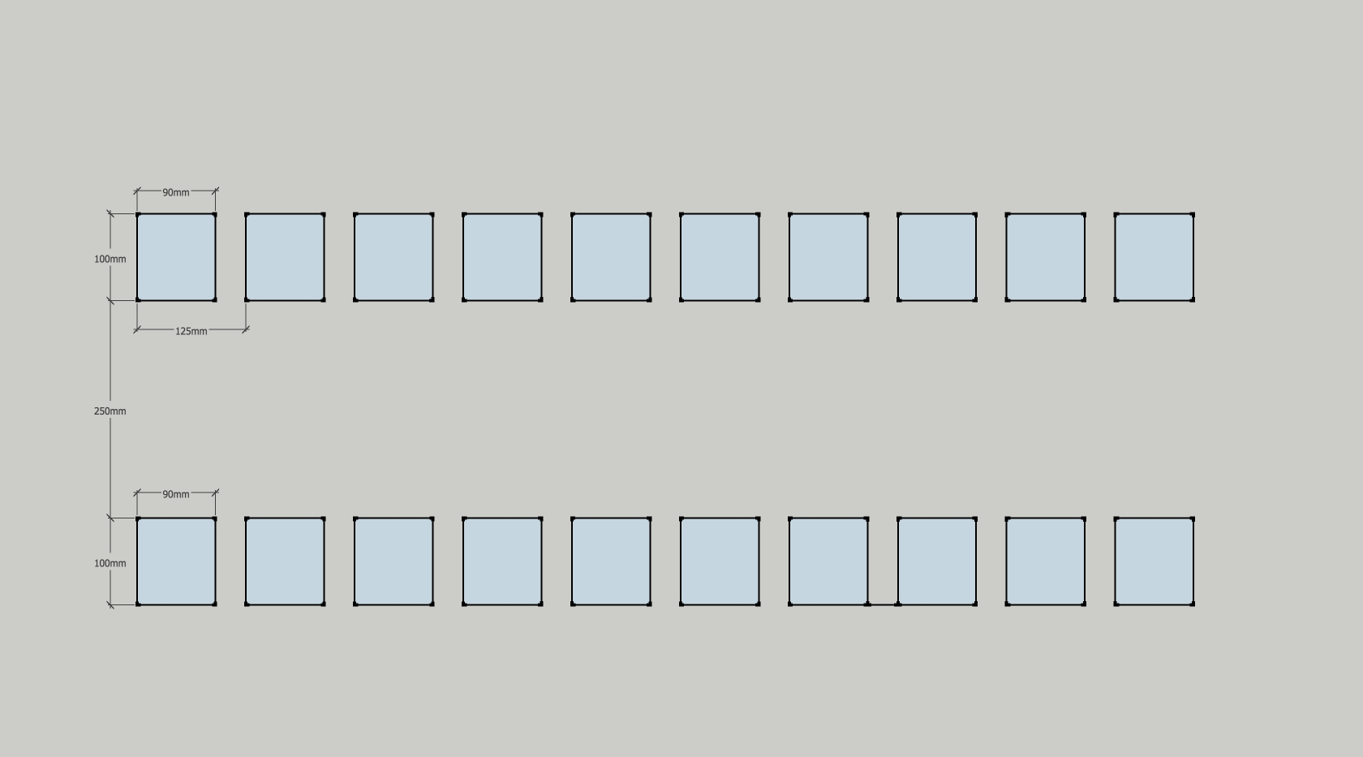

**250 m**

\\

**100 m**

**100 m**

**90 m**

**90 m**

**125 m**

**Test Structure**

**1**

**2**

**3**

**4**

**5**

**6**

**7**

**8**

**9**

**10**

**11**

**12**

**13**

**14**

**15**

**16**

**17**

**18**

**19**

**20**

**Figure 3.3.2: Pad Layout for Each Active Array at Center of Two Rows of 10 Pads**

### 3.3.1 Active Pixel Array Specifications

The active pixel arrays will have the following spatial specifications. For each set of specifications, 1 array will be included.

**Table 3.3.1.A: Active Pixel Array Spatial Specifications for HV-CMOS Technology**

|  |  |  |  |
| --- | --- | --- | --- |
| APA # | Pixel Dimensions | Diode Area Fraction |  |
| APA01 | 45 m x 100 m | 30% |  |
| APA02 | 45 m x 100 m | 50.4% |  |
| APA03 | 45 m x 200 m | 30% |  |
| APA04 | 45 m x 200 m | 50.4% |  |
| APA05 | 45 m x 400 m | 30% |  |
| APA06 | 45 m x 400 m | 50.4% |  |
| APA07 | 45 m x 800 m | 30% |  |
| APA08 | 45 m x 800 m | 50.4% |  |
| APA09 | 45 m x 200 m | 30% | Without contact ring around each pixel, but with contact ring around the entire array having a separate pad |
| APA10 | 45 m x 200 m | 30% | With contact ring around each pixel that violates the design rules by having a symmetric width |
| APA11 | 45 m x 200 m | 30% | With contact ring around each pixel that meets the design rules and a contact ring around the entire array having a separate pad |

**Table 3.3.1.B: Active Pixel Array Spatial Specifications for HR-CMOS Technology**

|  |  |  |
| --- | --- | --- |
| PPA # | Pixel Dimensions | Diode Area Fraction |
| APA01 | 40 m x 40 m | Few % |
| APA02 | 40 m x 80 m | Few % |
| APA03 | 40 m x 120 m | Few % |
| APA04 | 40 m x 200 m | Few % |
| APA05 | 40 m x 400 m | Few % |
| APA06 | 40 m x 800 m | Few % |

**Table 3.3.2A: Assignment of pads for Active Array in HV-CMOS Technology.**

**Table 3.3.2B: Assignment of pads for Active Array in HR-CMOS Technology.**

**{These tables can be filled in later as long as there is a figure with pad layout.}**

It is preferable that the amplifier included in each pixel is fast enough to allow separation of drift and diffusion components of the charge collection. Due to the time constraints, the target speed is to be according to a “best effort” scenario. The amplifier circuit included in each pixel will have the following electrical specifications:

**Table 3.3.3: Fast Amplifier Specifications**

|  |  |
| --- | --- |
| Risetime | <= 30 ns (3 ) for HV-CMOS;  ~ 100 ns for HR-CMOS {With this long rise time, it appears that the only way to separate drift from diffusion will be to measure diffusion with the bias off.} |
| Noise | <50 e- for HV-CMOS; {Confirm with Ivan} < 25 e- for HR-CMOS |
| Gain | On the order of 500 mV/fC {Confirm with Renato & Ivan} |
| ?? |  |

It is necessary that the inner 9 pixels have output routed to the probing pads for analog measurements. However, time-resolved digital readout can be additionally implemented if it does not interfere with the analog signals.

## 3.4 Isolated Fast Amplifier

An isolated example of the fast amplifier circuit used with the active pixel arrays will be included with an input and out pad. This is to separately test the characteristics of the amplifier in order to separate its characteristics and their evolution with radiation from that of the passive pixel sensors. The pad layout of Figure 3.3.2 will be used for this structure as well. Multiple copies of the amplifier will be included as can be serviced by the 20 pads. This is to allow testing of matching of amplifiers in close proximity to each other. It will also be necessary to compare the performance of amplifiers on several of the test chips available to test similar matching across a wafer.

### 3.4.1 Isolated Fast Amplifier Specifications

Substantially the same as what is used for Active pixel array in section 3.3.

**Table 3.4.1 Assignment of pads for Fast Amplifier in both Technologies.**

{This table can be filled in later as long as there is a figure with pad layout.}

## 3.5 Isolated Realistic Amplifier

A realistic amplifier should be included:

* An amplifier with “tuning knobs”, such as bias current, which can be used to find the technology limits with respect to noise, rise time, and power consumption when no special techniques are used to limit the rise time. {Ivan: I think that every amplifier on the chip, also the fast amps mentioned in previous sections, should have tuning knobs. We can reuse the bias block with dacs from my test chip.}
* If time permits, an amplifier plus comparator with time-walk correction will be included. In this case, probe pads at the amplifier output as well as the comparator output should be provided.

The pad layout will be the same as shown in Figure 3.3.2 and again multiple copies of the amplifier will be included in each structure as can be serviced by the 20 pads.

There is concern that there may not be enough time before the submission deadline to compete these two designs. If these two test structures cannot be completed in time for the submission deadline, then they should be left out rather than miss the submission.

### 3.5.1 Isolated Realistic Amplifier Specifications

**Table 3.5.1: Realistic Amplifier Specifications**

|  |  |
| --- | --- |
|  |  |
|  |  |
|  |  |
|  |  |

{These specs are yet to be determined. Does someone have suggestions?}

**Table 3.5.2: Assignment of pads for Realistic Amplifier in both Technologies.**

**{This table can be filled in later as long as there is a figure with pad layout.}**

## 3.6 Array of individual transistors, resistors and capacitors

In order to evaluate the characteristics of individual components of each technology, which will be important for further improvements to the active circuitry to be employed in the final CMOS sensor, an array of transistors, resistors and capacitors will be included.

The pad layout is to copy one already developed by CERN for such purposes. This will allow the use of a probe card already designed and in existence at CERN to test all the devices in this array. The organization of the device array consists of several blocks. Each block consists of two rows of 16 pads each with the devices (transistors, resistors or capacitors located between the two rows. The pad opening size is 76 m x 76 m; the horizontal pitch is 125 m and the pitch between the two rows in a block is 167 m. The pitch between the second row of one block and the first row of the next block is at least 100 m. The number of blocks to include depends upon how many devices to be included as given in Tables 3.6.1.A and 3.6.1.B. The actual assignment of device nodes to pads is not fixed by the test system at CERN, which can be configured to match the assignment of the test chip.

# 3.6.1 Specifications for Array of Individual Device Structures

A list of transistor types and sizes, resistors and capacitors along with the pads they are connected to are listed in table 3.6.1.A and 3.6.1.B. Many transistor drains and capacitor and resistor nodes will share common pads. The pad numbers in these two tables refer to the pad positions shown in Figure 3.6.1.



**Figure 3.6.1: Pad Layout for Array of Individual Transistors, Resistors and Capacitors**

**Table 3.6.1.A: Device Properties & Pad Assignments for HV-CMOS Technology**

|  |  |  |  |  |
| --- | --- | --- | --- | --- |
| Nmos in deep N-well | Width | Length | Guard ring | Pad Numbers (S, G, D) |
| Regular Nmos | 3µ | 1µ | ✗ |  |
| Circular Nmos | 3µ | 1µ | ✗ |  |
| Regular Nmos | 3µ | 1µ | ✓ |  |
| Circular Nmos | 3µ | 1µ | ✓ |  |
| Circular Nmos | 6µ | 1µ | ✓ |  |
| Circular Nmos | 5µ | 0.4µ | ✓ |  |
| Regular Nmos | 5µ | 0.4µ | ✓ |  |
| Circular Nmos | 50µ | 1µ | ✓ |  |
| Regular Nmos | 50µ | 1µ | ✓ |  |
| Circular Nmos | 50µ | 1µ | ✗ |  |
| Regular Nmos | 50µ | 1µ | ✗ |  |
| Nmos without Nwell | Width | Length | Guard ring | Pad Numbers (S, G, D) |
| Regular Nmos | 3µ | 1µ | ✗ |  |
| Circular Nmos | 3µ | 1µ | ✗ |  |
| Regular Nmos | 3µ | 1µ | ✓ |  |
| Circular Nmos | 3µ | 1µ | ✓ |  |
| Circular Nmos | 6µ | 1µ | ✓ |  |
| Circular Nmos | 5µ | 0.4µ | ✓ |  |
| Regular Nmos | 5µ | 0.4µ | ✓ |  |
| Circular Nmos | 50µ | 1µ | ✓ |  |
| Regular Nmos | 50µ | 1µ | ✓ |  |
| Circular Nmos | 50µ | 1µ | ✗ |  |
| Regular Nmos | 50µ | 1µ | ✗ |  |
| Pmos in Nwell | Width | Length | Guard ring | Pad Numbers (S, G, D) |
| Regular Pmos | 3µ | 1µ |  |  |
| Regular Pmos | 6µ | 1µ |  |  |
| Regular Pmos | 5µ | 0.4µ |  |  |
| Regular Pmos | 50µ | 1µ |  |  |
| Capacitors |  | Value |  | Pad Numbers |
| Pmos |  | 200fF |  |  |
| Pmos |  | 400fF |  |  |
| Pmos in Nwell |  | 200fF |  |  |
| Poly-poly |  | 200fF |  |  |
| Poly-poly |  | 400fF |  |  |
| Resistors |  | Value |  | Pad Numbers |
| RpolyHC |  | 10k |  |  |
| Rpol |  | 20k |  |  |
| Regular Pmos |  | 40k |  |  |

**Table 3.6.1.B: Device Properties & Pad Assignments for HR-CMOS Technology**

{Need to get this list from Renato.}

# 4 Top Level Chip Layout

The layout of the overall chip showing the locations of each type of test structure is shown in Figure 4.1. The active pixel arrays are located around the edge of the chip to allow possible wire bonding to a support test PCB. The passive pixel arrays and the array of transistors, resistors and capacitors will be probed without need for wire bonding.

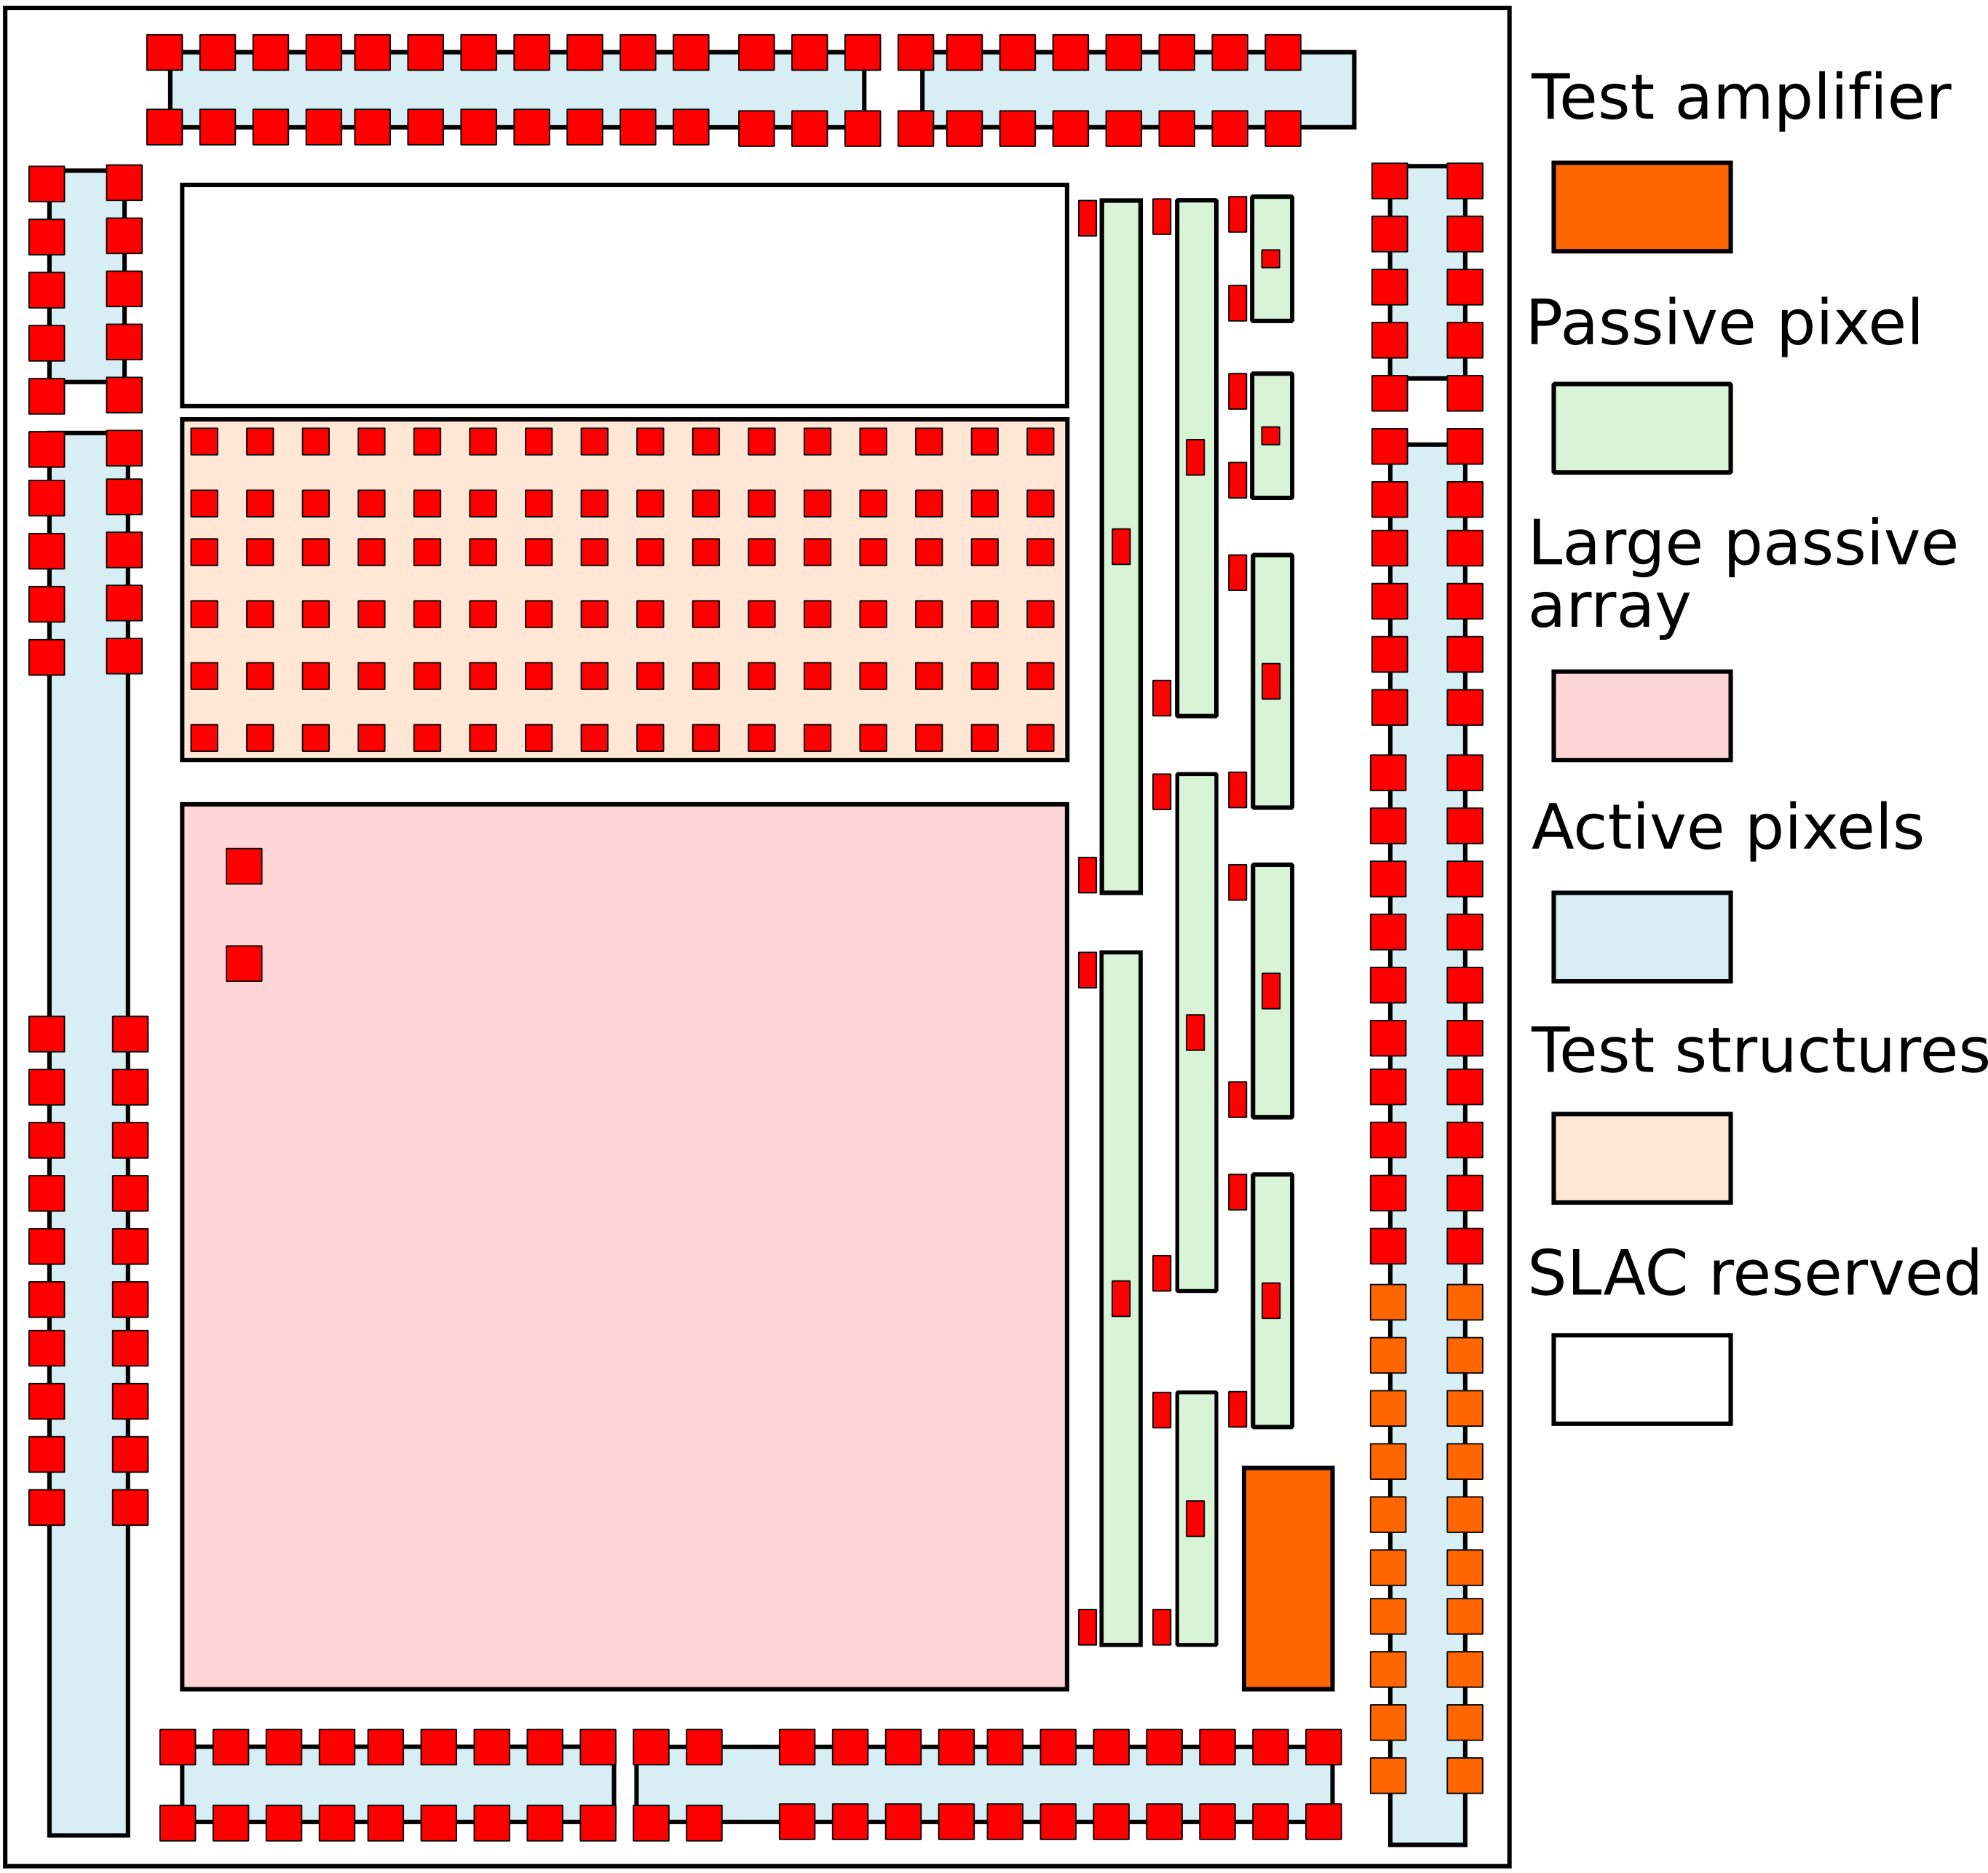

**Figure 4.1: Top View of the Full HV-CMOS Chip**

**This is our best estimate of the chip organization at this time. It’s size is 3.4 mm x 4.2 mm. It may change as the final layout of each test structure is completed.**

**Figure 4.2: Top View of the Full HR-CMOS Chip**

**{This needs to be provided by Renato.}**

# 5 References

1. M. Havranek, et al., “Measurement of pixel sensor capacitances with sub-femtofarad precision”, *NIM A714*, 83-89 (2013).