|  |  |  |  |
| --- | --- | --- | --- |
| MACHINE  LAYOUT  COORDINATION |  | | |
| Document Type | Specification | Document Number | see EDMS imprint |
| Life Cycle | Draft |  |  |
| Author | W. Decking | Affiliation | DESY |
| Version | 1.0 | Date | 17.11.2014 |
| Title | | | |
| **Infrastructure Requirements for the Hard X-Ray Self-Seeding Setup in the SASE1 and SASE2 sections of the European XFEL** | | | |

# Introduction

Self-seeding is an elegant way to increase the spectral brightness of SASE radiation. It consists of a crystal monochromator that is inserted into the SASE light pass at a suitable position within the undulator. The co-propagating electron beam has to bypass the crystal with the help of a magnetic chicane (see figure 1).

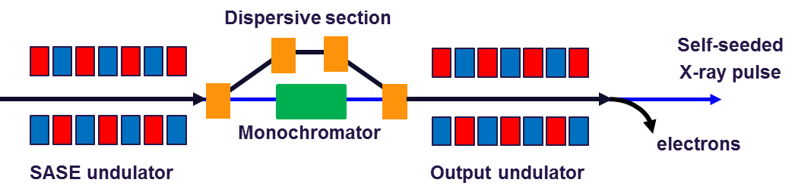

Figure 1: Schematic view of a self-seeding set up

This scheme has not been part of the XFEL baseline and funds have only become available recently. The implementation of the scheme has not been worked out in detail; nevertheless infrastructure installations should be prepared as far as possible to implement the set-up later.

Due to the large average power the XFEL is capable to deliver the specific set-up calls for two chicane installations per SASE beamline. The exact position cannot be specified at the time being and will be optimized once the performance of the accelerator is known.

The following table gives the possible installation positions:

|  |  |  |
| --- | --- | --- |
|  | Chicane 1 (Segment 4,5,6,7) | Chicane 2 (Segment 11,12,13) |
| SASE1 (TD2) | U40.2256.SA1 to U40.2275.SA1  2256 to 2275 m | U40.2299.SA1 to U40.2311.SA1  2299 to 2311 m |
| SASE2 (TD1) | U40.2218.SA2 to U40.2237.SA2  2218 to 2237 m | U40.2261.SA2 to U40.2273.SA2  2261 to 2273 m |

# Electron Chicane

At each self-seeding set-up a 4 bend electron chicane has to be added to the electron beam line. The complete chicane has to fit into 5 m length given by the undulator segmentation.

Installation of a self-seeding chicane in any of these sections requires additional infrastructure and hardware:

* 4 electro-magnetic dipoles with secondary coils for field correction
* Cabling
* Precision power supplies
* Magnet supports
* Connection to water cooling system
* New vacuum system

At present it is assumed that the chicane magnets can be based on the existing design of the XBL magnet with reduced yoke gap (50 mm to 16 mm) and increased rated current (145 A to 190 A), yielding the required 1.45 T magnetic field.

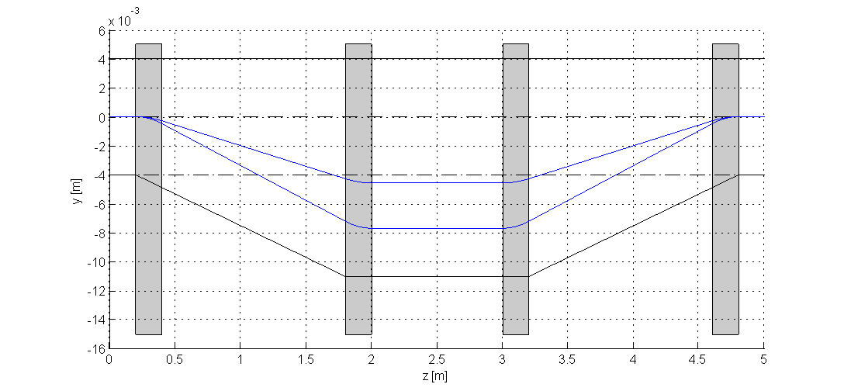

Figure 2: Example of electron chicane

In the following a first estimate of the magnet parameters is given, subject to verification

|  |  |
| --- | --- |
| Primary Winding | |
| Gap | 16 mm |
| Max. Field | 1.45 T |
| Max. Current | 190 A |
| Volt. Drop | 10 V |
| Power Loss | 2 kW |
| Secondary Winding | |
| Max. Field | 0.03 T |
| Max. Current | 10 A |
| Volt. Drop | 1 V |



Figure 3: 2D drawing of XBL magnet

# Summary of Infrastructure Requirements

## Magnet Current

SASE1 (2256 to 2276 m)

* Space for one 200 A / 60 V power supply to power 4 XBL type magnets
* Space for four10 A / 1 V corrector power supplies to power 4 XBL correction coils
* Appropriate Cabling from XS1 to 2276 m

SASE1 (2299 to 2311 m)

* Space for one 200 A / 60 V power supply to power 4 XBL type magnets
* Space for four 10 A / 1 V corrector power supplies to power 4 XBL correction coils
* Appropriate cabling from XS1 to 2311 m

SASE2 (2218 to 2237 m)

* One 200 A / 60 V power supply to power 4 XBL type magnets
* Space for four10 A / 1 V corrector power supplies to power 4 XBL correction coils
* Appropriate Cabling from XS1 to 2237 m

SASE2 (2261 to 2273 m)

* One 200 A / 60 V power supply to power 4 XBL type magnets
* Space for four 10 A / 1 V corrector power supplies to power 4 XBL correction coils
* Appropriate cabling from XS1 to 2273 m

## Magnet Cooling

SASE1 (2256 to 2276 m)

* Foresee up to 10 kW of additional cooling power

SASE1 (2299 to 2311 m)

* Foresee up to 10 kW of additional cooling power

SASE2 (2218 to 2237 m)

* Foresee up to 10 kW of additional cooling power

SASE2 (2261 to 2273 m)

* Foresee up to 10 kW of additional cooling power