Proposal
for a
Helmholtz Russia Joint Research Group

Physics Analysis and Calorimetry at the Tera - Scale

Executive Summary

The proposed project for a Helmholtz Russia Joint Research Group continues the long-lived and very fruitful cooperation between DESY and Russian Institutes beyond the common efforts for HERA experiments, physics and detector R&D towards new activities imminent at the LHC and for the future ILC. Within the project several excellent young Russian scientists and students are supported, opening the possibility for a future career in high energy particle physics.

The combination of physics and detector activities proposed in this Joint Research Group makes the project extraordinary and exceptional. The basis of the project is provided by the profound experience in detector operation and physics analysis collected at HERA. The gained knowledge flows directly into an imminent project at LHC and provides input to the projects for the future linear collider ILC. For a healthy project with future prospects it is mandatory to closely relate physics, experiment and the development of novel technologies for the next generation of colliders.

In the area of physics the results of HERA on the structure of the proton, the underlying event, multi-parton interactions and dependencies of several QCD processes will provide crucial input for searches of new physics phenomena and other studies at the LHC. Only the knowledge of their contributions will enable the unfolding of the basic physics processes from the measured detector signals. The understanding of the HERA results with their consequences for the LHC needs a strong effort in phenomenology. The studies for the physics analyses require significant computing resources and will be performed employing GRID facilities, especially the TIER 2 centre at DESY. Monte Carlo samples on large scale are needed and will be produced at this Helmholtz Analysis Centre. The gained experiences will provide valuable input for the operation and maintenance of TIER 2 centres being built in Russian institutes for the LHC and the ILC.

The correct extrapolation of HERA results into the kinematic regime of the LHC needs input of initial data to be taken with low luminosity in the start-up phase of the LHC with a special hadron calorimeter in the forward region. Members of the project will participate in the construction and operation of the calorimeter, cultivate skills obtained at HERA and develop further knowledge in detector operation. This activity is one component to preserve the experience until the construction and operation of the ILC detector will start.

One mainstream activity for an ILC detector involving both DESY and the participating Russian institutes is the development of a hadronic calorimeter. A novel technology was invented for its readout based on solid state photo-sensors, the so-called SiPM. Further optimization is needed to proceed from first successful test beam experiences towards a realistic and cost-effective detector device. It is mandatory to strongly pursue its optimization to keep the leading position in this successful development. Beside this novel technology new reconstruction algorithms for hadronic energy deposition are developed aiming at the distinct reconstruction of energy and particle flow, enabling new analysis strategies for the data analysis at the ILC, which is required to match the precision physics potential of this future high energy machine.

This proposal is centred on the development of experiments in high energy physics from HERA towards the LHC and the ILC. The proposed HRJG is tailored to allow efficient participation in this programme by selecting a few important key topics where existing expertise of participating Helmholtz and Russian institutes can be brought in and further developed. The HRJRG will bring together data analysis and detector experts from the HERA, LHC and ILC communities and catalyze the direct transfer of knowledge between them. This ensures that developments for the future take the as advanced as possible starting point and pay their return at the earliest date, possibly with a beneficial transfer already into the running experiment .The activities of the HRJRG fit naturally into the framework of the strategic alliance between DESY and German universities, recently proposed to the HGF.
Conducting the activities of the HRJRG as proposed in this document will strengthen the role of the participating Russian institutes and DESY in particle physics over the next years. The acquired experience in detector development and operation together with the expertise in data analysis and further development in phenomenology will provide the basis for a sustained, long-term participation in fore-front experiments of particle physics.

Motivation

The proposed project for a Helmholtz Russia Joint Research Group continues the long-lived very fruitful cooperation between DESY and Russian Institutes beyond the common efforts for HERA experiments and physics analysis towards new projects in near and far future. In the past joint projects excellent young Russian physicists could only rarely afford to stay in physics. This project offers several of them the possibility to develop an outstanding profile as high energy particle physicist. The project connects data analyses, detector development and operation, which are skills mandatory for a leading particle physicist. With these excellent profiles they obtain a real alternative to industry and the perspective for playing an important role in particle physics in future.
The combination of physics activities proposed in this Joint Research Group makes the project extraordinary and exceptional. Within the project mainstream activities followed up presently at DESY and the related Russian institutes are connected, which will naturally lead to more collaboration between the members involved in the three different activities.
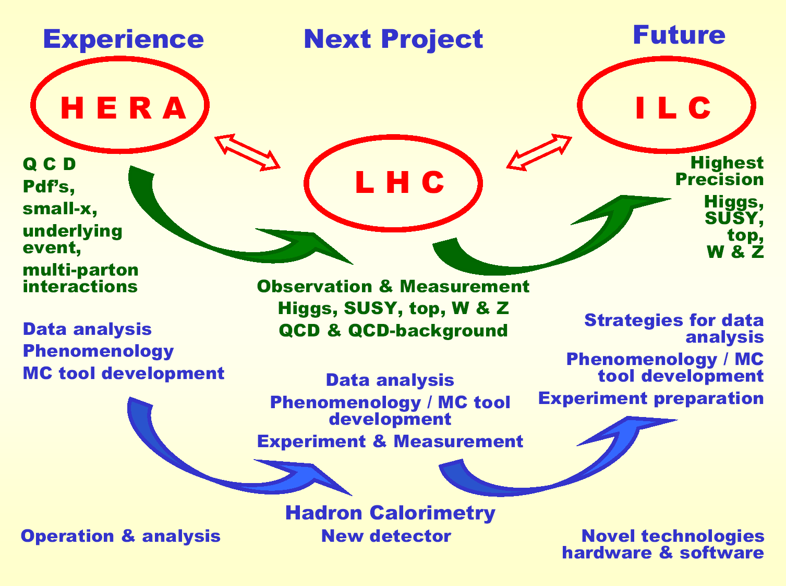
The basis of the project lies in the profound experience in detector operation and physics analysis collected at the electron-proton collider HERA at DESY. The gained knowledge flows directly into an imminent project at the proton-proton collider LHC at CERN and provides input to detector R&D for the future linear electron-positron collider ILC. For a healthy project it is mandatory to have physics, experiment and at the same time already the development of novel technologies for the next generation of experiments.

In the following all components of the proposal are described in detail and Figure 1 elucidates their close relation among each other.
Figure 1: Components of the proposed project for a HRJRG.
Introduction

The standard model of particle physics describes the interaction of sub-atomic particles employing three of the known four forces: the electro-magnetic and the weak, unified in the electro-weak force, and the strong force. Several different theoretical approaches exist to embed the fourth force, the gravitation, into this framework. Most models require a novel fundamental symmetry (super-symmetry, SUSY) predicting a wealth of new, fundamental particles. They are the SUSY-counter partners of the particles in the standard model and their spin is changed by one half. All the various models predict different phenomena, which can be tested experimentally only at extreme high energies, with very rare processes or with the existence of exotic particles. But also the predictions of the present Standard Model with its three basic forces are subject of intensive studies. Tiny deviations in the measurements from these predictions could hint indirectly to a possible extension towards a complete theory incorporating all four forces.

The Standard Model constitutes in its present form already since about 25 years the basis of elementary particle physics. It predicts properties and characteristics of the interactions between elementary particles in their structure, but not in their strength. Therefore several parameters, like the coupling constants and masses, of the Standard Model have to be determined and measured experimentally.

In the framework of the Standard Model the mechanism how the elementary particles obtain their masses is not finally determined. The usually adopted solution is the Higgs mechanism which leads through symmetry-breaking to elementary particles with masses. As a consequence a so-called Higgs particle must exist. It is looked for at all present high energy experiments, but up to now such a Higgs particle has not yet been observed and it is the challenge for the next collider, the very high energetic proton-proton collider, the Large Hadron Collider (LHC) at CERN, to find it. The LHC will start its first data taking within the next year. The task for a future linear collider with electrons and positrons, the International Linear Collider (ILC) will be the accurate measurement of its properties with highest precision. The same is envisaged for the SUSY particles mentioned earlier. It is hoped to observe them at LHC and then to measure their properties in every detail at the ILC.

Beside the not yet observed elementary particles also the structure of composed particles like the proton cannot yet be derived from the standard model. They need to be measured with highest precision, since they enter strongly into all predictions of interactions. The determination of the structure of the proton is one of the primary goals of physics analyses at the electron-proton collider HERA at DESY, finishing its 15 years data taking in summer this year.

The project consists of different components in two major areas:
- Physics analysis:
  - The expertise in data analysis and results of HERA on QCD will provide crucial input for precision measurements at LHC, the structure of the proton, the underlying event and multi-parton interactions are strongly influencing the precision of the measurements.
  - Deeper understanding of the evolution of the structure of the proton, of the mechanisms of underlying event production and multi-parton interactions is needed to be able to model these aspects correctly in Monte Carlo simulations. Therefore studies in phenomenology are included in this project as well as their verification with HERA data.
  - The analysis of top quark production at LHC has been chosen as physics topic for a first application of the newly developed concepts, since it will be also one focal point of physics analyses at ILC.
- Instrumentation:
  - The extrapolation from HERA to the LHC needs initial measurements at LHC with a hadron calorimeter in the forward region. Contributions to its construction, operation and data analysis belong to one area of activity of this proposal.
  - For the hadron calorimeter of the ILC detector a novel technology for the readout has been developed, the so-called Si PM. The optimization of this technology from pioneering applications towards the employment in the ILC detector is one central activity of this HRJRG. Optimized models for the hadronic shower evolution in simulations as well as novel reconstruction methods are being developed in this area. They will give new impulses for the exploitation of the data of the forward calorimeter at LHC.

Physics Analyses:

The physics part of the project is given by contributions from HERA and the LHC providing valuable input to the physics at the ILC. At first the present status of knowledge is described. The goals of this proposal for a HRJRG are given in the following paragraphs as well as the steps to be taken towards their achievement.

Present Status:

HERA:

Hadrons like the proton or the neutron are composed of elementary particles, so-called partons. These are different kind of quarks and connecting particles, the gluons. The structure is usually parameterized in terms of parton density functions (pdfs), which give the probability to find a certain quark or a gluon as a function of the momentum-fraction x of the proton and as a function of Q², the negative squared four-momentum transfer in the interaction. In this context Q² denotes the resolution with which it is possible to measure this certain parton. The higher Q², the better the resolution, but also the more rarely the scattering process is.

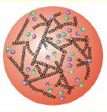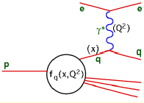

Figure 2: Left: An artist’s view of the composition of protons out of partons, different kind of quarks (dots) and gluons (spirals). Right: Electron-Proton scattering at HERA for the determination of the proton structure in terms of parton density functions, here the quark density function f_{q}(x,Q²).

Parton distribution functions (see Figure 2) are measured with very high precision at HERA. It was one of the first discoveries at HERA that the structure function of the proton is strongly rising towards values of small x and increasing Q². The evolution of the parton densities with x and Q² are described by calculations within perturbative Quantum Chromodynamics (QCD), the theory of the strong interaction. Different approaches exist to describe the rising of the structure function of the proton as a function of increasing Q², as a function of decreasing x and a combination of both. These approaches usually employ the collinear factorization scheme to calculate the cross sections for processes using the parton density functions and the matrix elements for the basic parton interaction. In another scheme more recently developed scheme the so-called kt-factorization is employed, which uses un-integrated parton density functions and different matrix elements. The determination of these un-integrated parton densities from HERA data and the calculation of the basic matrix elements for several processes at LHC are items to be worked on in this HRJRG.

The rise of the structure functions cannot continue at this pace towards smaller x and higher Q². Therefore it is predicted by theory that at some stage it has to be tamed by mechanisms of saturation, employing recombination processes for gluons. This has not yet been clearly observed at HERA. But indicative hints exist also from measurements at RHIC, a heavy ion collider at BNL producing partons at very high densities. The impact of the parton distribution functions on any calculation of processes at LHC is very strong and it is obligatory to measure them at HERA with the highest possible precision. Knowing how the pdfs have been derived and where the main uncertainties are, will help to employ them correctly for LHC physics. Essentially this means that tools and methods developed in data analyses at HERA will be successfully ported to the LHC.

Mainstream analyses at the LHC are concentrating on searches for Higgs and SUSY signals and on studies of top-, W- and Z- production. The latter are aiming for a determination of not predicted Standard Model parameters and for an identification of possible deviations from Standard Model predictions which could indirectly hint to the correct model for the unification of the four forces. Colliding protons with protons at LHC it is obvious that the structure of the proton has to be known with highest accuracy to limit the uncertainty. The input of HERA results on the uncertainty of LHC measurements can be demonstrated with the example of W-production: taking into account the precise HERA measurements of the structure of the proton at HERA decreases the uncertainty on W-boson production at the LHC from 16% down to 3.5%.

Most new phenomena searched for at the LHC suffer from different QCD background processes. Since one mainstream topic of HERA physics is QCD, a lot of data and many tools are available to study the different QCD background processes which can contribute at the LHC. Understanding their dependencies at HERA will help to unfold signals of new physics phenomena from background at LHC in a safe way.

Closely related to the (non-linear) effects of saturation in the evolution of the structure of the proton are the phenomena of diffraction and the phenomena of underlying event distributions and multi-parton interactions. These can be derived from very general considerations of high energy cross section calculations using the so-called AGK cutting rules, which have been recently extended to QCD processes. In the next section it will become clear why it is mandatory to understand the contributions from the underlying event and multi-parton interactions before the cross sections for new processes at the LHC can be unfolded with sufficient precision.

LHC Contribution:

At the LHC protons collide with protons. This means essentially a bunch of partons collides with another bunch of partons. This is displayed schematically in Fig.3.

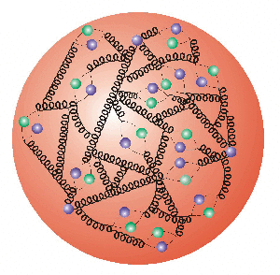
Figure 3: An artist’s view on proton proton collision at LHC. The red arrows denote the basic parton parton interaction which is under study. The black arrows show produced particles which were produced in additional soft interactions between the partons in the proton remnants. In green the tracks of particles produced in a second parton interaction are drawn.

In addition to the hard interaction between one parton of each proton soft interactions between the partons left over in the protons and parton showers with additional particles lead to a so-called underlying event with specific energy offsets. In the data analysis this energy offset has to be subtracted from the energy of detected jets, bundles of particles produced by the scattered partons after the hard interaction. Only with the correct knowledge of the contribution of the underlying event it is possible to derive the energy of the original parton from the hadronic final state of an event with sufficient precision. Additional hard interactions between two partons of the protons can lead to mis-identifications of the basic physics process. This can be explained with the example process pp → W + H + X , where the W-boson and the Higgs are produced in one interaction through one quark from the first beam proton and one anti-quark from the other beam proton with the subsequent decays W→ l + ν and H → b bbar. This process has the same final state as one proton proton collision with two-parton interactions: pp → W + b bbar +X, where the W-boson is produced by a quark anti-quark interaction and the b bar pair by an additional gluon-gluon interaction. The cross section for this two-parton interaction has a similar size as the production of a W-boson and a Higgs in one single-parton interaction.

Multi-parton interactions and the structure of the underlying event have been studied also at previous hadron colliders as well as at the presently running Tevatron at the Fermi National Laboratory. Measurements have been used to tune the parameters of the models for multi-parton interactions in different physics generators for Monte Carlo simulations. Although the Tevatron data, measured with a centre of mass energy of 2 TeV, could be sufficiently well reproduced, a large uncertainty of a factor of three in the extrapolation of the different models and tunes towards the new kinematic regime of the LHC with 14 TeV centre of mass energy remains.

This example demonstrates clearly, that the basic mechanisms of the underlying event production and the multi-parton interactions have to be understood. All analyses at the LHC need this input to be able to unfold the basic physics from the detector signals with sufficiently small uncertainty. Studies, similar to those performed at the Tevatron, are in progress to provide first estimates. They concentrate on particle signals in the central region of the detector. There the tracking devices can measure low energetic particle with high precision.

In preliminary studies it revealed that especially the forward region can provide crucial input to measure the contributions and to study the basic mechanisms of multi-parton interactions. This fact becomes clear by looking at Fig. 4, where the pseudo-rapidity η of particle production is indicated. This variable is a measure of the scattering angle. The region presently analysed in initial studies is the central region around the interaction point: |η|<1.

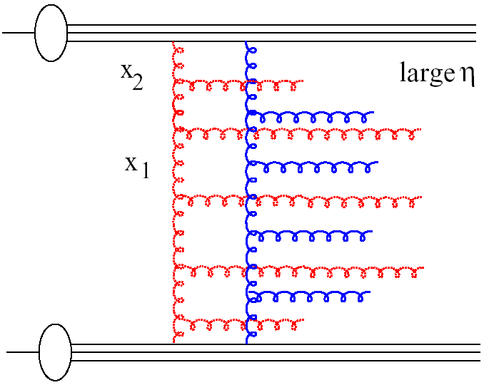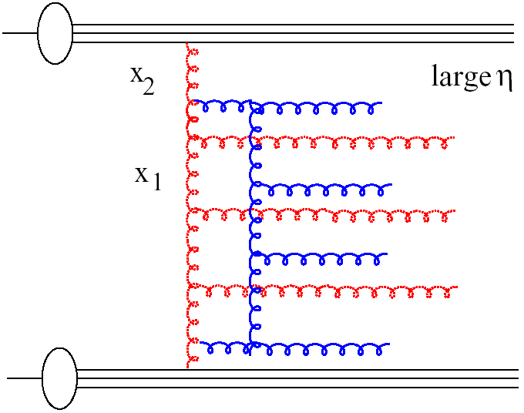
central
Figure 4: Two different physics processes. The interaction in the left process is mediated by two gluon ladders. In the right process the second gluon ladder is initiated only later in the first gluon ladder. While in the central region the processes cannot be distinguished, in the forward region they are sufficiently different.

The CASTOR calorimeter located in the forward region of the CMS experiment can provide important insight into this problem and it is therefore part of the proposed HRJRG (see below). Monte Carlo simulations on the generator level have been performed to study the possibilities opened up by analysing data in the CASTOR region of 5.3<|η|<6.6. The results are given in Fig.5.

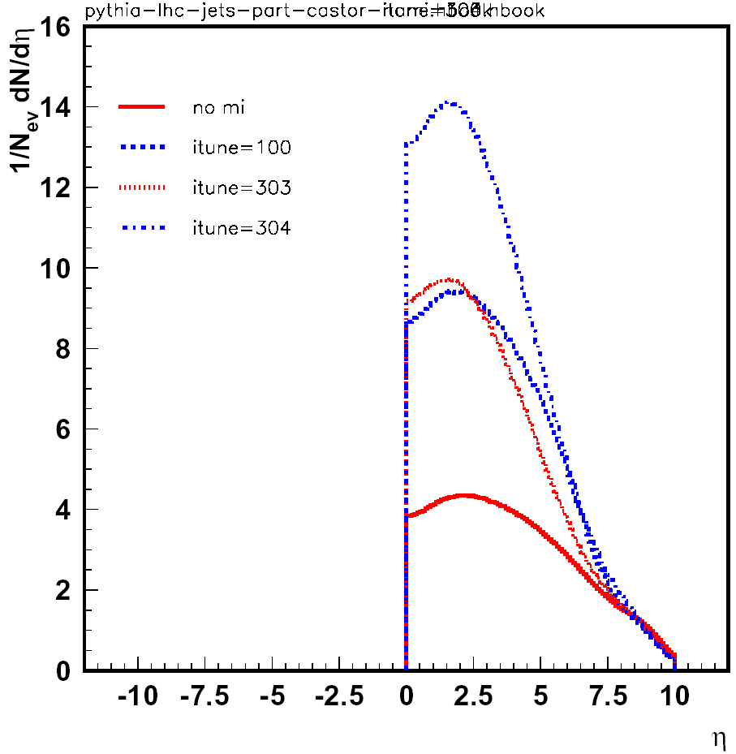
no MI
TuneA
SO
high MI

Figure 5: Multiplicity in the central and the forward region as produced in minimum bias events with four different generator settings for the modelling of multiple interactions. The full red line marks the result for simulations with no multiple interactions. The blue dashed-dotted line denotes a simulation with the other extreme: a lot of multiple interactions. The two curves in the middle represent two more or less realistic tunings to the Tevatron data.

Considering charged particle multiplicity the difference in the prediction between the two realistic models is only about 15%, while in the η-region of CASTOR the difference amounts to a factor 1.5 to 2. For a deeper understanding of multi-parton interactions the study of long range correlations in the particle production might give insight into the basic mechanisms. Here the question is asked, if the mean charged multiplicity in the central region with |η|<1 changes if a high energetic jet is detected in the forward region. Such long range correlations are already suggested by the process diagrams illustrated in Figure. 4.

As displayed in Fig. 6, in case of no multiple interactions in the Monte Carlo simulation the mean charged particle multiplicity is independent of any jet in the forward region. However, when taking into account multiple interactions long range correlations are seen: the mean charged multiplicity increases with increasing energy of the jet by a factor of 2. In addition the different models give significantly different predictions. Here one has to keep in mind, that the mean multiplicity can be measured with good precision since the individual values in the curve are averages over a large number of events.

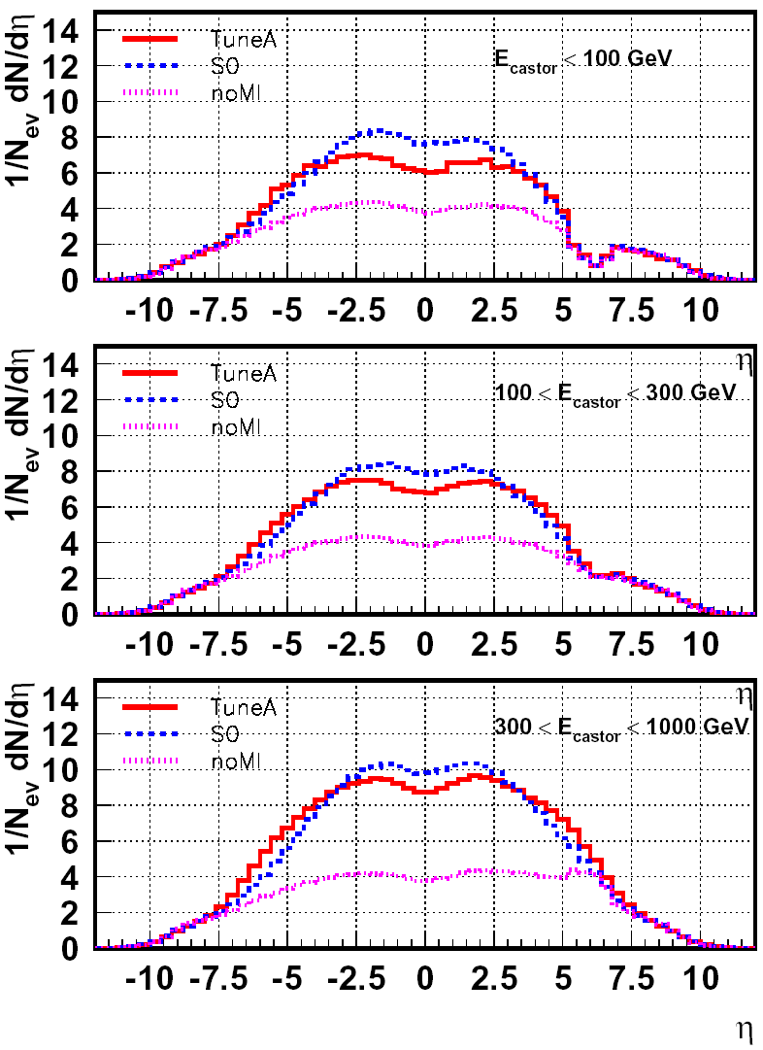

central forward
no correlation
long range correlation

Figure 6: Left: with long range correlations the multiplicity in the central region depends on the multiplicity (and energy) of the trigger particles in the forward region. Right: Resulting multiplicities in the detector when requesting three different energy depositions in the CASTOR calorimeter.

This study provides a new tool for the investigation of the underlying event structure and multi-parton interaction and will be followed up within the physics analyses in the HRJRG. Having understood the underlying event production and the contributions from multi-parton interactions it will be possible to implement them correctly into the Monte Carlo generator. In turn these can be used to unfold the different contributions to all processes under study for precision measurements. Also this task is part of the activities of the HRJRG.

In addition to studies of multi-parton interactions, other aspects of QCD at largest energy can be investigated. As a rule of thumb two units in pseudo-rapidity corresponds to one order of magnitude in x. Forward jets in the CASTOR region can probe values in x down to 10⁻⁴. Drell-Yan pairs produced in this rapidity region could go down to even 10⁻⁷ if small enough masses in the order of 2 GeV are produced. The accessible area at LHC in x and Q² is shown in Fig. 7, where also the kinematic range of HERA is indicated.

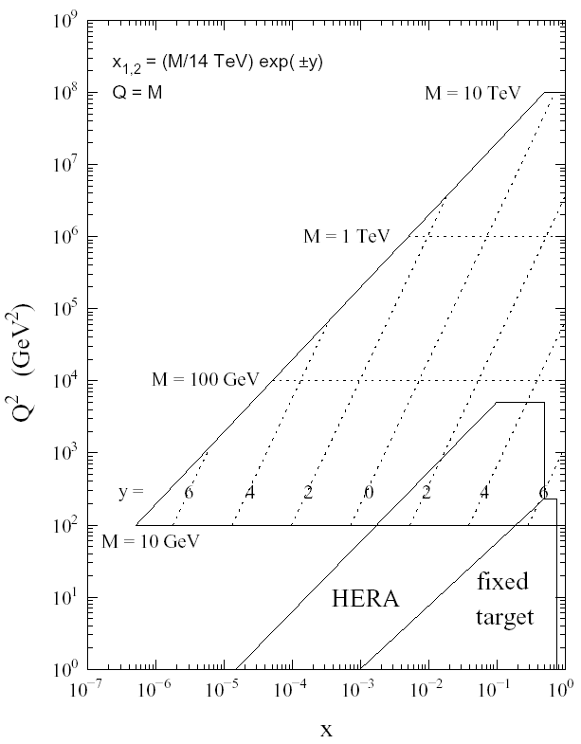
Figure.7: Kinematic region in x and Q² accessible with LHC and compared with HERA. The approximate region which can be probed with pseudo-rapidity range of the CASTOR calorimeter is marked in red.

Beside the discussed crucial aspects of underlying event, multi-parton interactions and parton dynamics at small-x the physics with the CASTOR calorimeter comprises several other important aspects some of them listed in the following:
- In studies of diffraction it can be used as a selection tool. In these specific events a strong interaction is mediated by a colour neutral exchange with quantum numbers of the vacuum. Diffractive physics will be easy to study in the beginning of the data taking, because its cross section constitutes almost ¼ of the total cross section and necessary statistics will be collected within a short time. Diffraction is a physics analysis topic intensively studied at HERA.
- The measurement of energy- and particle flow will provide crucial input for cosmic ray data analyses. The modelling of the hadronic component is not well determined at these very high energies. The measurements at LHC are equivalent to data at the 100 PeV scale in the cosmic ray framework and will provide distinctive information for the various models.
- Two photon interactions, where a photon is emitted by each of the beam protons, can be studied with this calorimeter as a selection tool.
- In Heavy Ion runs at the LHC it will provide access to physics topics pursued for example in ion collisions at RHIC with a new kinematic range and be used to search for new forward phenomena in the very high density region of parton interactions.
- The analysis of pairs of leptons, e+ e- or μ+ μ-, which are produced via electro-magnetic interactions will provide accurate information on the luminosity.

For the study and determination of the underlying event and the contribution of multi-parton interactions initial measurements right at the beginning of the LHC data taking is mandatory. At the start-up of the data taking it is expected that the luminosity will be small enough such that pile-up of events from collisions of different protons in the beam bunch does not compromise the proposed measurements. Therefore it is important that the CASTOR calorimeters can be constructed and installed before the start of the data taking, which needs a start of the project at the earliest possible date. Further detail on this instrumentation component of the HRJRG activities are given in the section Calorimetry at LHC and ILC.

One component of the activities in this HRJRG will be the application of the analysis results on the proton structure functions, underlying event and multi-parton interactions to one of the mainstream analyses at the LHC: the top-quark production. Fundamental top quark properties will be studied with unprecedented precision at the LHC, complementing the Tevatron measurements and providing strong sensitivity to Standard Model parameters such as the mass of the Higgs boson. In particular, the top – anti-top spin correlations will be clearly accessible for the first time at the LHC. Those measurements will allow tests for alternative top quark production mechanism such as the decay of a Higgs boson or narrow heavy resonances. Top quark interactions with gauge bosons will be studied and possible indications for anomalous top quark decays via Flavour-Changing-Neutral-Currents or decays to a charged Higgs boson will be searched for. The large mass of the top quark suggests that it plays a very special role in the electroweak symmetry breaking.

It is important to measure precisely differential cross sections in top - anti-top production at the LHC. The production as well as the decay of top quarks is predicted in the Standard Model with rather good precision. Therefore precise measurements of differential cross sections allow for instance the cross check of parton density functions at high momentum transfer between HERA and LHC and permit conclusions on new physics which in some models manifests in top final states due to its high mass.

At the ILC more is to be learned about the top quark as the favourable experimental conditions allow for even higher precision. For example the top mass can be determined about 10 times more precisely form a threshold scan of top - anti-top production

The most likely and most widely studied extension of the Standard Model is super-symmetry (SUSY). If realized in nature we expect the super-symmetric masses to be in the range for a discovery and later detailed investigations at the LHC and the ILC, i.e. at the Tera-Scale. This is suggested for instance from the unification of forces which at very high energies requires new states at the Tera-Scale. In this case the experiments at the LHC will be able to establish evidence for SUSY and determine masses and mass differences of some of the new states. The LHC can extend the sensitivity to the multi-TeV range exploiting the missing transverse energy signature. In such SUSY analyses the important role of calorimetry is evident.

Again, more insight can be gained at the ILC once SUSY has been established at the LHC. New particles states can be disentangled exploiting the adjustable energy and the possibility of polarisation of the colliding electrons.

One common item within this HRJRG is, as mentioned already above, the application of the analysis results on proton structure function, underlying event and multi-parton interactions. In addition common interests arise from the selection and reconstruction of the event candidates for top – anti-top production via the semi-leptonic decays. Here jets and multi-jets have to be measured with good precision, which needs optimized jet cluster algorithms and accurate jet energy calibration. The same items are vital components of the analyses of forward jet production. Experience and tools from HERA analyses will provide a good starting point in this area.

Goals of the HRJRG, planned activities and milestones

The ultimate goal is to observe and measure Higgs and new particles at the LHC.
The strategy to achieve this goal is briefly summarised in the following list.

In order to safely identify these particles and phenomena several studies have to be performed:
- The production of multi-jets, of W- and Z-bosons and of heavy quarks like top and bottom has to be understood.
For precise measurements it is necessary to
- know the contributions from the underlying event and from multi-parton interactions. Proper implementation of their processes in the simulation programs is a pre-requisite for reliable estimates.
- measure the parton density functions of the proton at small-x and large scale with highest possible accuracy.
The above items need input and cross checks with:
- measurements of the multiplicity and energy flow in the forward region, also correlated with the central region. These measurements will help to understand the basic mechanisms and their implementation in Monte Carlo generators.
- measurements of Drell Yan pairs and jets in the forward region which are especially sensitive to the parton density functions at small x.

The tasks of this list are distributed among six of the participants of the proposed HRJRG and will be performed in parallel.
In the area of phenomenology:
- Matrix elements for the production of W- and Z-bosons as well as for jets and multi-jets and for new particles have to be calculated using the k_{t} factorization scheme ( - mid of 2009).
- the implementation into Monte Carlo generators (2008-2009) and verification (2009-2010).
- development of a model for underlying event and multiple interactions and implementation into the Monte Carlo Generator, verification with data (2008-2010).
In the area of physics data analysis several tasks will be followed up:
- measurement of D* + jet production at HERA and extraction of the un-integrated gluon density needed for the calculations in phenomenology (2008-2009)
- measurement of forward jets at HERA (2008)
- mean charged particle and energy flow analysis:
  - further simulation studies (2008),
  - initial data analysis (2009)
  - measurement (2010)
  - and combination with jets in the forward region (2010)
- jet analysis:
  - reconstruction and calibration in the forward region (2009-2009)
  - initial studies for double parton interactions (e.g. γ + 3 jets, as seen by CDF at Tevatron)
- top – anti-top production:
  - development of data selection and reconstruction, esp. jets (2008-2009)
  - measurement (2010)
While at HERA the conduction of the measurements is done almost by one person, it has to be kept in mind while reading the list, that the analyses at LHC will be performed in a larger group of collaborators. The mentioned items will therefore be in most cases contributions to the work of the group.
The PI from DESY (KB) and one of the ITEP key researchers (AR) are recognized experts in forward physics and will strongly contribute to the realization of this programme. An efficient connection to the CMS analysis effort will be provided by one of the DESY key researchers (JM), who is coordinator of the CMS top quark physics group and leader of the DESY CMS group.

Relation with other programmes:
Most of the activities proposed for this HRJRG were initiated by studies performed in the framework of the HERA-LHC workshop. This workshop was started in a joint effort by DESY and CERN in 2004 and is continued after the first year with several meetings on the basis of yearly meetings. Within the HERA-LHC workshop a group of physicists of DESY and different Russian institutes, mostly experts in forward physics, formed in 2005 an initiative to study small-x, underlying event and multi-parton interactions at LHC. Some members of this group will participate in the HRJRG.

Calorimetry at LHC and ILC

The instrumental part of the proposal is divided into two main activities. One is the construction of components for a forward calorimeter for the CMS Experiment (CASTOR). The other one is the further development of the novel technology of Si PM in connection with the hadron calorimeter for the ILC detector. Since calorimeters are an integral part of any high energy physics experiment it is well justified to foresee several activities to further develop this instrument, especially novel technologies applicable in this area.

HERA:

With the operation and maintenance of detector components at HERA a lot of experience has been collected which will be helpful for the operation and maintenance of components in LHC experiments. Especially for the forward region at HERA several calorimeters have been designed, constructed, operated and their data been analysed in various different physics aspects. Having dealt with detector signals and their analysis for about 15 years will provide valuable input for the analyses at the LHC and at ILC.

LHC: Forward Calorimeter in CMS Experiment

The CMS experiment which has the best coverage in the forward region is the LHC experiment chosen for this HRJRG project. While DESY joined recently the CMS collaboration, Russian institutes are members already since a long time being deeply involved in design and construction of the experiment components and in studies for physics analyses.

Contributions on the experimental side are possible in the area of the CASTOR project in the CMS collaboration. On both sides of the experiment a small radiation-hard hadronic calorimeter is foreseen see Fig. 8 and Fig. 9.

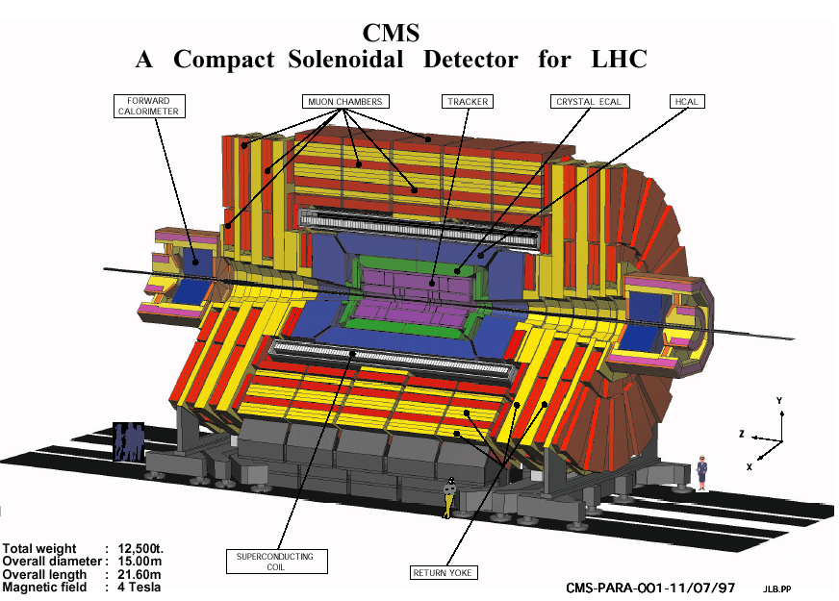
CASTOR
5.3 < η < 6.6

Figure 8: Schematic layout of the CMS Experiment. Its very large dimensions become clear by comparing it to the size of the people drawn in the bottom of the picture.

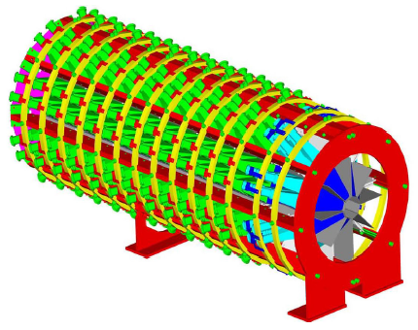
Figure 9: Layout of the CASTOR calorimeter (1.2m long, 0.6m diameter). The Cerenkov light produced in Quartz plates, alternating with Tungsten layers, are read out via radiation hard photo multipliers around the calorimeter. The blue area indicates the electromagnetic section and the green one the hadronic section. In front of the calorimeter a tracking device is placed by the TOTEM collaboration, which shares the same interaction region as the CMS collaboration. This tracker will provide valuable spatial information about the incoming particles and will be able to measure the flow of particles.

Here a vivid and fruitful cooperation with the group studying hadronic calorimetry for the future detector at the ILC can be established. While profiting for LHC analyses from the newest developments for the reconstruction of hadronic calorimeter signals as created from the ILC group, the input from the measurement with higher granularity will help to understand and to tune the simulation of hadronic showers. Operating this calorimeter will deliver new information for the tuning of the simulation of hadronic showers and optimizing the reconstruction algorithms, both delivering crucial input for the developments for the ILC detector.

The CASTOR project is in the final design phase. Test beam measurements have been performed twice with prototypes of initial designs; new test beam measurements with the final design are scheduled for August 2007. This project has been initiated in the framework of physics with heavy ion data from LHC but has a large potential for studying other key questions as outlined above. In order to achieve these goals it is mandatory to perform the measurements at low luminosity, where almost no pile-up from consecutive events is expected. This low luminosity will be available at the start-up of LHC until the optimization of the machine will lead more or less to the nominal high luminosity. It is therefore very important to have the CASTOR calorimeters ready and installed in spring 2008.

Goals, planned activities and milestones

The goal for this part of the instrumental project is the realization of at least one calorimeter for spring 2008. The planned contributions to the hardware of the calorimeter are:
- The mechanical construction of the calorimeter (2008): DESY has taken over the construction of a pre-prototype of smaller length. For the construction several mechanics parts necessary for the needed strength require a complicated production. These parts are well suited to be produced in a well equipped laboratory as DESY (2007-2008).
- The readout electronics where several different readout boards are suitable to be produced and tested in Russia and at DESY. Productions costs and funding for the necessary test equipment is included in the relevant tables (2007-2008).
- The infrastructure with the purchase of cables and connectors and their installation (2008).

The activities of four of the participants of the HRJRG comprise:
- work for the design, production and test of electronics readout boards (2008)
- analysis of the test beam data from 2007 with tuning of hadronic shower simulation (2008-2009)
- implementation of consequences for the CASTOR calorimeter in the CMS simulation software (2008-2009)
- Participating in the commissioning, calibration, alignment, data taking and data analysis (2008-2010).

The PI from DESY (KB) has long-standing experience in construction and operation of calorimetric systems in leading positions and is presently coordinating the CASTOR hardware effort at DESY. One MSU key researcher (IK) is presently responsible for the operation of the Silicon based ZEUS hadron electron separator system. Both will contribute with their expertise to a professional completion of this detector project.

Relation with other programmes:
CASTOR group within the CMS collaboration consists of 15 international institutes from 7 countries, including 4 different Russian institutes. In this framework several applications for funding are underway in different countries. The possible approval of the HRJRG proposed in this document, will clearly have positive impact on the approval of these applications and give a significant boost towards the completion of the project.
The operation of the CASTOR calorimeter in a radiation-harsh environment will provide valuable experience for SLHC-oriented detector R&D and will thus support applications for future projects in this direction.

ILC: HCAL project

Present status of joint activities:
Precision physics at the ILC imposes challenging performance demands on calorimetry which require highly segmented detectors and novel readout technologies. DESY, ITEP and MEPHI successfully cooperate since many years in the development of scintillator-based hadron calorimeters read out with the latest generation of Silicon photo sensors.
These devices, so-called SiPMs, due to their high gain, small size, operational robustness and low cost open new possibilities for revolutionary detector design. They have become available only recently (2004) for the first time in larger quantities from Russian industry, as a result of a cooperation between MEPHI and DESY which dates back into the 1980s. Today, ITEP and MEPHI are world-wide leaders in development, mass production and characterization of SiPMs for high energy physics applications.
This high end technology has also a wide range of applications beyond particle physics, for example in medicine (positron emission tomography), bio-technology and radiation detection. In this HRJRG project, the first large-scale application of this multi-use technology will be pursued.
Together with DESY, a first multi-channel detector has been built and is being examined in test beams at DESY, CERN and FNAL. This first detector with its 8000 SiPMs directly mounted on scintillator tiles (Figure 10) already demonstrates the suitability of the new high technology for ILC calorimetry. In the further test beam programme it will collect the data necessary to promote our understanding of the fine structure of hadron showers and to develop in parallel the simulation and reconstruction software for making optimal use of the detailed information from a highly granular calorimeter.

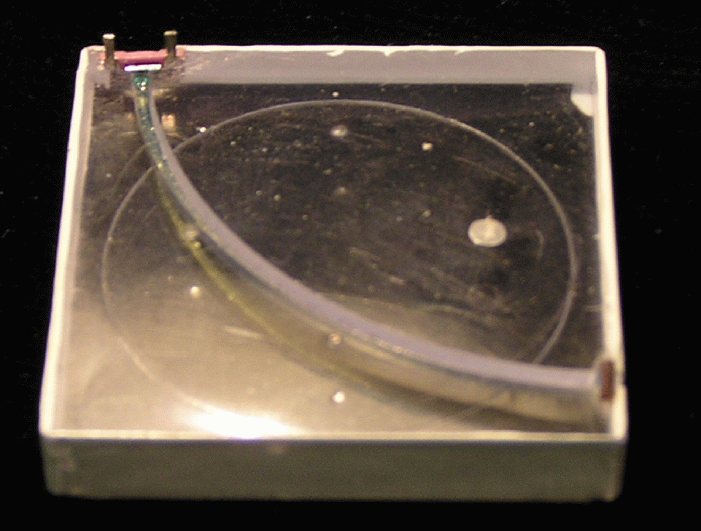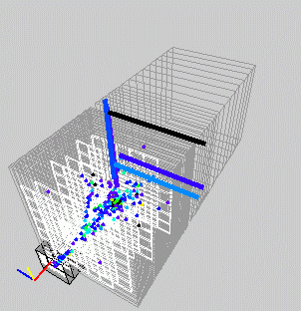
Figure 10 Scintillator tile (3x3cm²) with SiPM (left); hadron shower recorded during test beam measurements with a prototype calorimeter (right).

The concept of this detector with embedded photo-sensors emerged from R&D work pursued in close collaboration between ITEP, MEPHI and DESY. The MEPHI group has pioneered the development of SiPMs and the optimization of their parameters to match the requirements for application in a scintillator-based calorimeter in terms of high efficiency, low noise and sufficient dynamic range. ITEP was leading the R&D effort to match spectral responses of scintillators and wavelength shifters to the sensor characteristics, to find technical solutions for the integration of the sensor scintillator system, and to develop a quality control chain suited to mass production, which is unparalleled in the worldwide detector community. DESY as coordinating institute had a major role in providing test infrastructure to evaluate various options and carry out crucial beam tests with a 100 channel pre-prototype, in the development of readout and calibration electronics in close collaboration with French, British and Czech partners, and in the overall detector integration, construction and commissioning.
The mutual benefits of this strategic partnership were decisive for the institutes to attain the presently held leading position in the field. The coordinating role of DESY was instrumental for the Russian groups to integrate their technological leadership into the world-wide collaborative effort with a scope much beyond what is possible for a small number of groups. On the other hand, the close contact with ITEP and MEPHI is a strategic advantage for DESY because it incorporates the crucial adaptation of the solid state photo-sensor technology in the overall optimization of the detector system. This goes beyond the usual perspective of a customer to photonics producers and provides much extended possibilities to address the design with an integrated view.

Goals of the future cooperation and milestones:
In the next years, the technology needs to be developed and optimized further, in order to proceed from the pioneering test beam experience towards a realistic and cost-effective proposal for an ILC detector, which should be prepared by the end of the decade when first physics results and possibly signatures for exciting new physics phenomena will become available from the LHC. This challenge goes beyond a straight-forward engineering effort, since no precedence for a scintillator-based detector with embedded photo-sensors and front end electronics exists so far.
To meet the goal, further R&D is needed both for the active readout layer electro-mechanical design which must integrate the microelectronics readout chips and minimize the cost-sensitive thickness of the readout gap, as well as for the optimization of the scintillator SiPM system. Operational experience and analysis results from the ongoing test beam programme are expected to significantly influence this development.
The sensor performance needs to be improved, in order to provide leeway to arrive at a simpler and at the same time more compact design. Higher efficiency and lower noise allow to reduce the scintillator layer thickness, and to simplify the optical coupling of the sensor as required for large-scale mass production. The optimization of the scintillator composition and production process, with the goal to maximize the optical signal and to match it to the photo-sensor, works into the same direction.
Within the framework of this HRJRG, ITEP and MEPHI propose to jointly proceed in this development. It is planned to improve the infrastructure in both groups with new equipment for spectro-photometric analysis of the optical signal transfer (ITEP) and for probing micro-electronics sensors (MEPHI). These investments into test infrastructure will create the working conditions at the Russian sites which are necessary to make the next steps in R&D and to consolidate the technology and the long-term involvement of the Russian groups.
In parallel, DESY plans to work on the design of an active readout layer which takes the constraints from scintillator and photo-sensor optimization into account. Furthermore the DESY group will be actively commissioning newly developed highly integrated front end electronics from European collaborators and investigate its interplay with the existing and the optimized photo-sensors.
Milestones in this programme are
- Completion and analysis of the present prototype beam tests (2008)
- Development of an optimized SiPM scintillator cell for an integrated readout layer (2008)
- Development of a small readout layer prototype with integrated electronics (2008)
- Construction of a compact active layer for a scalable hadron calorimeter (2009)
- Commissioning and tests of the new modules in particle beams (2010)

The HRJRG will thus strengthen the competitiveness of our Russian partner institutes and allow them to continue in their leading role at the forefront of scintillator-based calorimetry. At the same time, it will support DESY in its role as a hub for detector development in Europe, propagate a successful cooperation into the era where the ILC effort is expected to gain momentum from the first physics outcome of the LHC, and enable DESY and its partners to have a highly visible impact on the ILC experimental programme.
The fact that one of the DESY key researchers (FS) presently acts as EUDET coordinator for calorimeter infrastructure and is involved in leading functions in the ILC calorimeter development will ensure that the HRJRG effort is well embedded into the international calorimeter community and connected efficiently to developments and infrastructure in a wider activity.
In summary, the proposed HRJRG programme for the ILC calorimeter represents a coherent R&D effort which will consolidate a break-through in Russian high technology and form a basis for a sustained leading contribution to the field.

Relations with other programmes:
The importance of the pursued activities has been acknowledged recently by the approval of the EU-funded EUDET integrated infrastructure initiative for detector development led by DESY, where realistic mechanical structures and readout systems for calorimeters are being prepared. They are envisaged to serve as test environment for the new generation of active detectors to be developed at ITEP and MEPHI, which are also associated with EUDET. The proposed HRJRG activities would therefore ideally complement the EUDET programme and optimally exploit the created infrastructure.
In addition the HRJRG proposal is related to research activities carried out by a Helmholtz Young Investigator group at DESY which works on SiPM applications in physics and medicine.

The hadron calorimeter development has a strong analysis and simulation component, namely the detailed study of the hadron shower cascade using large samples of test beam data, the validation and improvement of simulation programmes, and the development of novel reconstruction algorithms. The results of these studies are in fact also relevant and beneficial to hadron calorimeters at today’s and tomorrow’s collider experiments; they can be used to improve the resolution of the detector for final states with reconstructed jets and to reduce systematic uncertainties from modelling its response.

The HRJRG will bring together calorimeter analysis experts from the HERA, LHC and ILC communities and catalyze the direct transfer of knowledge between them. This ensures that developments for the future take the as advanced as possible starting point and pay their return at the earliest date.

