PETRA IV Scientific Instrumentation Proposal
template TITLE

- Science Case (1 A4 page, max. 2 Figures)
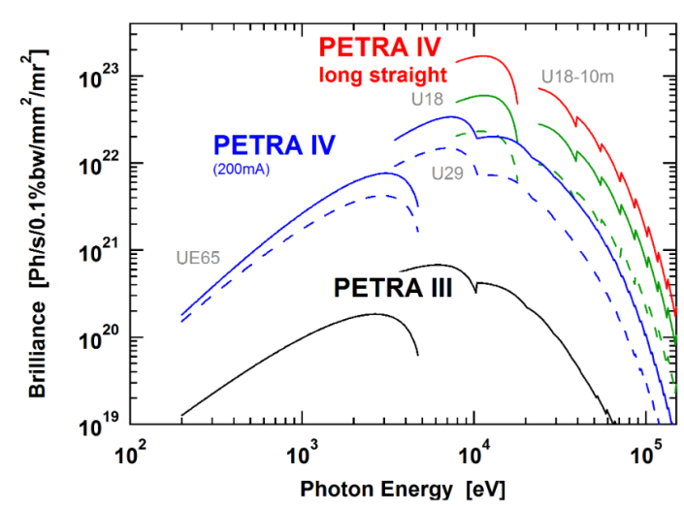
Lorem ipsum dolor sit amet, consetetur sadipscing elitr, sed diam nonumy eirmod tempor invidunt ut labore et dolore magna aliquyam erat, sed diam voluptua. At vero eos et accusam et justo duo dolores et ea rebum. Stet clita kasd gubergren, no sea takimata sanctus est Lorem ipsum dolor sit amet. Lorem ipsum dolor sit amet, consetetur sadipscing elitr, sed diam nonumy eirmod tempor invidunt ut labore et dolore magna aliquyam erat, sed diam voluptua. At vero eos et accusam et justo duo dolores et ea rebum. Stet clita kasd gubergren, no sea takimata sanctus est Lorem ipsum dolor sit amet.
Lorem ipsum dolor sit amet, consetetur sadipscing elitr, sed diam nonumy eirmod tempor invidunt ut labore et dolore magna aliquyam erat, sed diam voluptua. At vero eos et accusam et justo duo dolores
Fig. 1: kasd gubergren, no sea takimata sanctus est Lorem ipsum dolor sit amet. asd gubergren, no sea takimata sanctus est Lorem ipsum dolor sit amet.
- Motivation / Scientific Background
- Results expected and their scientific impact
- Novelty statement

- Experiment Description (1 - 2 A4 pages, max. 2 Figures)
Lorem ipsum dolor sit amet, consetetur sadipscing elitr, sed diam nonumy eirmod tempor invidunt ut labore et dolore magna aliquyam erat, sed diam voluptua. At vero eos et accusam et justo duo dolores et
- Sample environment (Travel range, Size, Pressure, Temperature)
- Detector (Specifications, Angular range, Pixel size, Frame rate)
- Data Acquisition (Required computational power, Data analysis tools, Rapid data reduction and analysis for real‐time feedback, Expected amount of data/day !!, Real-time
data analysis of detector required)
- Experimental setup (Goniometer, 3D tomography stage, gas cell, …)
- Technical equipment

- Explanation of the use of PETRA IV Parameters (200 words)
ea rebum. Stet clita kasd gubergren, no sea takimata sanctus est Lorem ipsum dolor sit amet. Lorem ipsum dolor sit amet, consetetur sadipscing elitr, sed diam nonumy eirmod tempor invidunt
- Importance of PETRA IV
- Focus size / Flux / Energy resolution /Element sensitivity / Spatial Coherence
- Faster data acquisition, Extension of coherence technique to high photon energies
References
- Moritz et al. “odododo” Science 34, 9 (2020)

