Straightness evaluation for the KEK electron/positron linac using a level*
T. Kume#, M. Satoh, T. Suwada, K. Furukawa, KEK, 1-1 Oho, Tsukuba, Ibaraki, 305-0801, Japan.
E. Okuyama, Akita University, 1-1 Tegata gakuen-machi, Akita, 010-8502, Japan.

Abstract
We adopted straightness measurement using a level for evaluating vertical aligning straightness of the alignment base plates for the 600-m-long KEK electron/positron injector linac (KEK injector). It measures tangential angles of the aligning straightness and obtains the straightness by integrating the angles without affected by any straightness references.
Here, straight bar was put on between each center of the neighboring base plates and slope angles of the bar were measured sequentially by a level on it. A pair of contact feet was adopted under both ends of the bar for preventing plate distortions from affecting the measurements. Offsets and drifts of the angle measurement system were eliminated or reduced by reversal measurement.
As a result, aligning straightness with the average standard deviation (σ) of 26 μm for 71-m-long part of the KEK injector could be obtained. It was compared with the measurements by a telescope and our developing laser based alignment system. They agreed well with each other and it shows that they are fairly reliable.
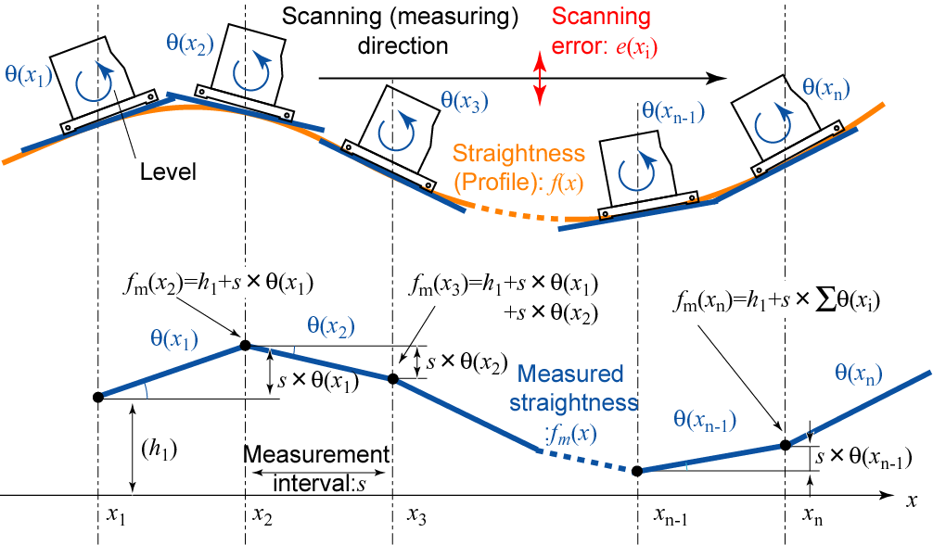
Figure 2: Straightness measurement using a level.
Error estimation based on our error propagating model shows that straightness measurement with reproducibility (2σ) of 0.6 mm for a distance of 500 m, and that of better than 1 mm for a distance of 10 km can be achieved with this method. They are sufficient for aligning the KEK injector and expected for aligning linacs considered in the ILC project, respectively.

Introduction
The KEK injector[1] having two straight sections, 125-m-long and 483-m-long (figure 1) is expected to be aligned with its straightness (lateral aligning accuracies against its ideal beam line) of better than 1 mm for coming upgrade, while two linacs with length of over 10 km considered in the International Linear Collider (ILC) project[2] are expected to be aligned with its straightness of better than 1 mm for distances from several 100-m to several km.
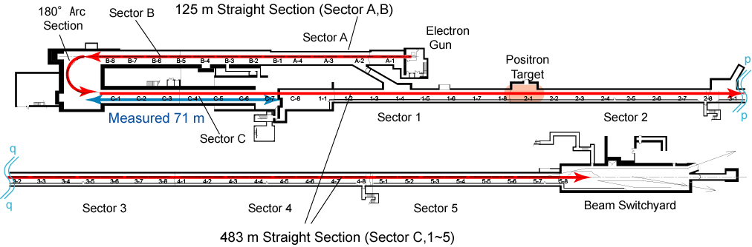
Figure 1: Top view of the underground section of the KEK electron/positron injector linac in the accelerator tunnel. Two cross sections “p-p” and “q-q” are connected and form a 483-m-long straight section.
On the other hand, straightness measurement by using a level has been applied for precise alignments from ancient. This method is considered to have advantages for long distance measurements, being hardly affected by straightness references.
We have studied to apply this method for evaluating aligning straightness of large particle accelerators highly precisely. [3], [4]

STRAIGHTNESS MEASUREMENT
Schematics of the straightness measurement using a level are shown in figure 2. Slope angles of each measurement points are obtained by a level. Straightness (profile) is derived by integrating the measured angles without affected by scanning error or error in straightness reference: e(x_{i}). The straightness f_{m}(x_{n}) at position x_{n} is derived as

$f_{m}\left(x_{n}\right)=h_{1}+s×\sum_{i=1}^{n−1}{θ\left(x_{i}\right)}$, (1)

where h₁, s, θ(x_{i}) are arbitrarily defined straightness of the start point: x₁, measurement interval, and slope angle at each measurement point x_{i}.
The KEK injector consists of accelerator units expressed in figure 3. Accelerator components are typically mounted on alignment base plates. The plates are considered as vertical position references. They are constructed on a 9-m-long steel pipe girder.
We evaluated vertical aligning straightness of the base plates. The slope angles between the neighboring base plates were measured sequentially using a precise electronic level system, Talyvel 4 (Taylor-Hobson), having measurement range of +/-3 mrad and resolution of 0.5 μrad.
The level was put on a straight bar on between each center of the base plate as shown in figure 4. This is for ensuring continuity of aligning straightness between the discretely-aligned base plates. We used 3 kinds of straight bars, considering intervals of each plates. Two of them were 25-mm-high and 50-mm-wide aluminum rectangular-pipes with the pipe-thickness of 3 mm. They are 1998 mm and 2306 mm long, respectively. The other was a 25-mm-high, and 50-mm-wide aluminum solid-bar with the length of 1640 mm.
We used two pairs of contact feet under both ends of the straight bars. The one is a pair of machined aluminum blocks with contact area of 50×160 mm and height of 50 mm. The other is a pair of optical parallels with contact area of 50×50 mm, thickness of 2 mm and flatness of better than 633 nm. The former was used with the solid bar and the latter was used with the pipe bars. They are for preventing plate distortions affecting the measurements and for avoiding obstacles in measurement.
We eliminated offsets of the angle measurement system by reversal measurement shown in figure 5. Slope angle to be detected: θ_{r} is obtained without affected by the offset: θ₀ as

$θ_{r}=\frac{θ_{m}−θ_{n}}{2}$, (2)

where θ_{m} and θ_{n} expresses the measured angle for before and after the reversal measurement. They are expressed as θ_{m}=θ_{r}+θ₀ and θ_{n}=-θ_{r}+θ₀, respectively. The offset θ₀ is delived as

$θ_{0}=\frac{θ_{m}+θ_{n}}{2}$. (3)

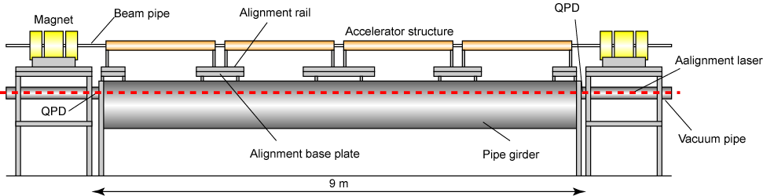
Figure 3: Side view of the typical accelerator unit.
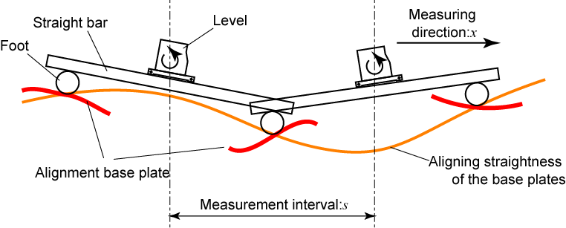
Figure 4: Straightness measurement using a level with straight bars and pairs of contact feet.
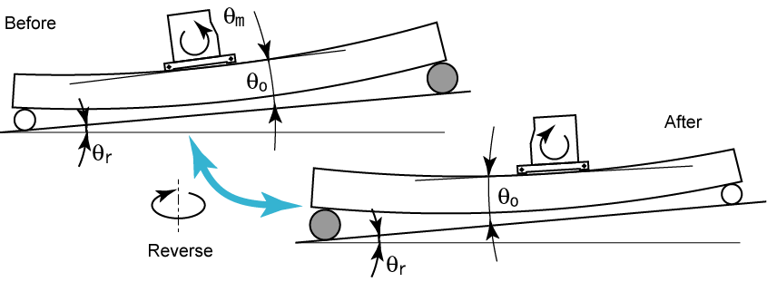
Figure 5: Reversal measurement for the angle measurement system consists of a level, a straight bar and a pair of contact feet.
Figure 6 (a) shows slope angles: θ_{r} and offsets: θ₀ obtained for between the 38 base plates in the 71-m-long part of the KEK injector. They are averages for the four times of repeat measurements during successive three days. Here the average measurement interval: s was 1.9 m. It took 2 to 4 hours for each measurement. The magnitudes of the offsets θ₀ are comparable to those of the slope angles θ_{r}. It expresses that the offsets must be eliminated and that the reversal measurement is effective to eliminate the offsets.
Figure 6 (b) shows their standard deviations. The standard deviations of the slope angles θ_{r} are smaller than those of the offsets θ₀. It expresses that the long time fluctuations of the offsets (drifts) are effectively reduced by each reversal measurement.
The aligning straightness of the base plates is shown in figure 7 (a). It is expressed with the measurements by a telescope and our developing laser based alignment system for comparison. [5], [6] They agree well with each other and it shows they are fairly reliable. Figure 7 (b) expresses standard deviations for the 4 times of repeat measurements. They have average of 26 μm and maximum of 49 μm, respectively.

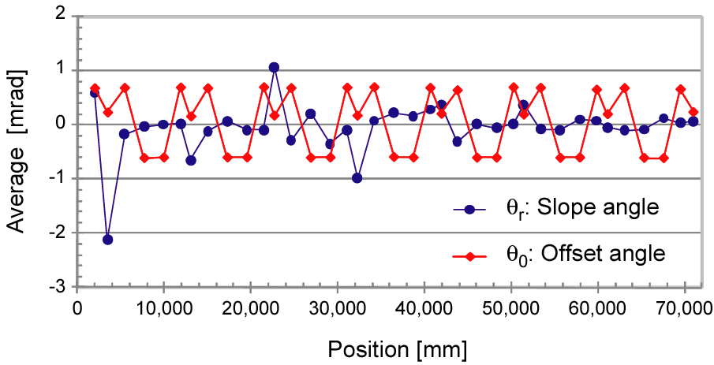
(a)
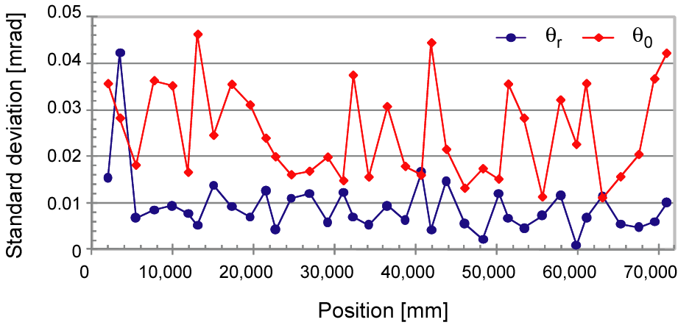
(b)
Figure 6 (a): Average of the slope angles: θ_{r} and the offsets: θ₀ and (b): their standard deviations. They are for the four times of repeat measurements.

Error estimation
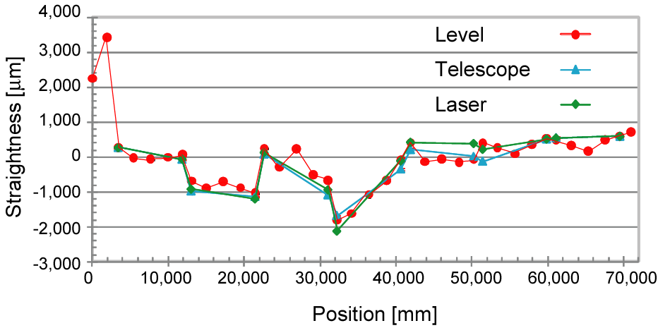
(a)
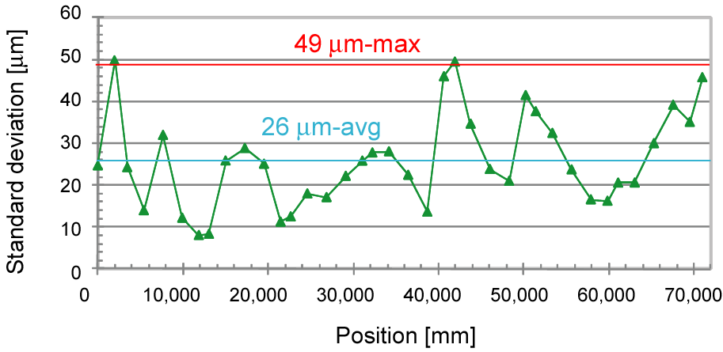
(b)
Figure 7 (a): Average of the straightness obtained from the 4-times of measurements with results of a telescope and our developing laser based alignment system. (b): standard deviations of the derived straightness for the 4-times of measurements.
Assuming that error in each θ(x_{i}) for the equation (1) is random and that it propagates to the error in the derived straightness f_{m}(x_{n}) as the error propagating rules, error in the derived straightness σ_{p} can be estimated as

$σ_{p}=\sqrt{s⋅l}⋅σ_{\text{ma}}$, (4)

where s, l, σ_{ma} expresses the measurement interval, the measurement distance and the error in each slope angle θ(x_{i}).
Estimated errors for two measurement intervals, s=1.9 m (open circles) and 20 cm (triangles) are shown in figure 8. Here, 1.9 m is the average measurement interval in our measurements. They are the two standard deviations (2σ) obtained by using equation (4) with σ_{ma}=9 μrad, that is the average standard deviation in our measurements.
The achieved (filled circles) are better than the estimated one (s=1.9 m). The reason has not yet resolved; however, the tendency that achieved one is better than estimated one is not a problem in practical usage.
The error estimation shows that straightness evaluation with the reproducibility (2σ) of 0.6 mm for the distance of 500 m, which is sufficient for aligning the KEK injector, can be achieved, using the measurement interval s of 1.9 m. Moreover, it shows that straightness evaluation with the reproducibility (2σ) of better than 1 mm for the distance of 10 km, which is expected for aligning the over 10-km-long linacs planned in the ILC project, can be achieved, using a measurement interval s of 20 cm.

Figure 8: Accuracy in straightness as a function of the measurement distance.

CONCLUSION
We adopted straightness measurement using a level for evaluating aligning straightness of the 600-m-long KEK injector.
Reversal measurements are effective for eliminating offset and reducing drift of our angle measurement system.
Straightness measurement with the average standard deviation (σ) of 26 μm for 71-m-long part of the KEK injector was demonstrated. The straightness agreed well with the measurements by a telescope and our developing laser based alignment system and it shows that they are fairly reliable.
Error estimation shows that straightness evaluations for aligning both the KEK injector (0.6 mm-2σ for 500 m) and linacs planned in the ILC project (better than 1 mm-2σ for 10 km) can be achieved with this method.

ACKNOWLEDGEMENTs
Authors thank Yukinori Kobayashi and members of the Accelerator Division 7 in Accelerator Laboratory in KEK and Masahiro Katoh of Institute of Molecular Science for providing us Talyvel 4. Authors also thank Yohsuke Iino, Kunihiko Sakai and members of Toyama co., ltd. and Mitsubishi electric system & service co., ltd. for providing us measurements by a telescope and supporting our studies.

References
[1] I. Abe, et al., “The KEKB injector linac”, Nucl. Instr. and Meth. A 499, (2003) 167.
[2] http://www.linearcollider.org/
[3] T. Kume et al., "Straightness alignment of linac by detecting slope angle,“ IPAC10, Kyoto, WEPEB055.
[4] T. Kume et al., "Long distance straightness measurement using a level, “ ISMQC 2010, Osaka, F6.
[5] M. Satoh et al., "Experiments on laser-based alignment at the KEKB injector linac,“ IPAC10, Kyoto, WEPEB056.
[6] T. Suwada et al., "New laser-based alignment system for the 500-m-long KEK electron/positron injector linac", IPAC10, Kyoto, WEPEB057.

