SUrvey of KEKB magnets and monuments for superKEKB
M. Masuzawa# and Y. Ohsawa, KEK, Tsukuba, Japan
N. Abe and K. Mishima, PASCO Corp., Tokyo, Japan
Abstract
A survey of the KEKB [1] main magnets and monuments was carried out using laser trackers for the next-generation B-factory machine called SuperKEKB [2]. A reinforcement of the alignment survey network is being carried out by adding new survey monuments on the tunnel wall and floor. Preliminary results of the survey are reported.

introduction
New monuments need to be installed for the magnet installation and alignment for SuperKEKB. SuperKEKB aims to achieve a peak luminosity of 8×10³⁵ cm⁻² s⁻¹ with the so-called “nano-beam” scheme [2]. SuperKEKB will be built in the existing KEKB tunnel, which was constructed about three decades ago. All of the main dipole magnets in the Low Energy Ring (LER) will be replaced by longer dipole magnets, and the magnets in the entire interaction region as well as in the straight sections on either side of the interaction point (IP) will be replaced. New wiggler sections will be added to the High Energy Ring (HER) and the layout of the wiggler sections in the LER will be changed to reduce the beam emittance. A significant amount of magnet installation and precision alignment are needed for the “nano-beam” scheme, and the magnet work will have to be completed in time. The survey network is being reinforced by adding approximately 1300 new monuments on the tunnel walls, floor and other infrastructure [3]. A survey of the new monuments and the existing KEKB magnets was performed and a preliminary set of positions of the monuments, a geodetic network, was obtained.

Need for New Geodetic network
When the KEKB magnets were first installed in the TRISTAN tunnel in 1997, there was no sophisticated geodetic network to be used. There were only floor monuments, which indicate the central positions of the removed TRISTAN quadruple magnets, as shown in Fig.1.
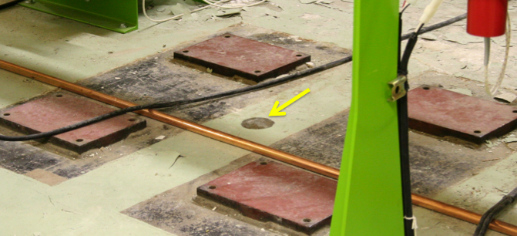
Figure 1: Old TRISTAN monument is indicated by an arrow. The four plates had been used as base plates for the magnet support.
The TRISTAN floor monuments are located at approximately 8 m intervals along the 3 km circumference. The layout of the KEKB rings is shown in Fig. 2. The LER and HER beam lines lie side-by-side, with about a 1 m separation between them.

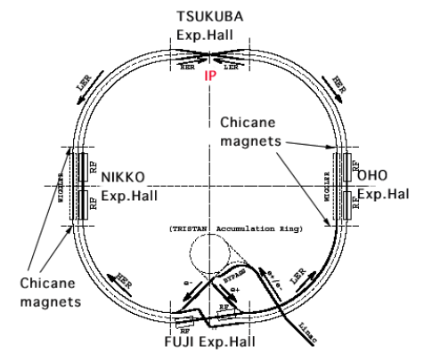
Figure 2: KEKB layout. Two beams collide at the IP in the Tsukuba experimental hall.

The required alignment accuracy of the KEKB magnets was achieved by repeating the survey of the magnets themselves over the entire tunnel several times [4]. Since this was an iterative process, it was time consuming.
We decided to survey the old monuments, and reinforce the geodesic network for SuperKEKB by adding more monuments. A new survey is needed for the following reasons:
- A part of the tunnel continues to sink, as shown in the following section, which can cause a deformation of the tunnel.
- The complete removal and reinstallation of the magnets on both the left and right sides of the IP is needed. The straight section on the left side of the IP is shown in Fig. 3. As can be seen, the beam lines in the straight section are completely new. On the other hand, some of the arc section magnet positions are preserved. Consistency between the new beam lines and the remaining parts from the KEKB beam lines is critical. A simultaneous survey of the existing magnets and new monuments is needed.
- The monuments, which are more densely and evenly distributed in absolute coordinates, should be helpful when installing the magnets locally, especially when the construction schedule is as tight as it is for SuperKEKB.
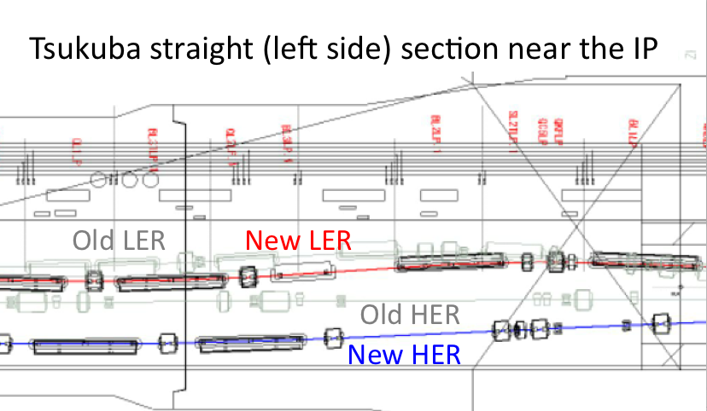
Figure 3: The old KEKB beam lines (grey) and the new SuperKEKB beam lines (red and blue). The new beam lines are completely different from the old ones.
Approximately 1300 new monuments have been installed so far on the floor and on the wall, to be surveyed with a laser tracker and a digital level [4]. Figure 4 shows the wall monument, which can be used for a 1.5 inch reflector and a scale bar.
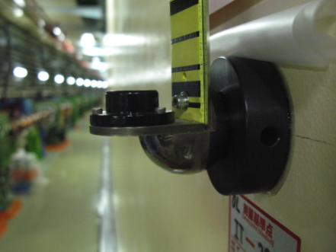
Figure 4: Newly installed wall monument.
The surveying network is constructed as successive unit rectangles, ~8 m in length and ~2 m in width. In the actual surveying process, an approximately 32 m long area (equivalent to four of the unit rectangles) was covered by one tracker setup (station). Since we shift 8 meters between successive surveying steps, each measurement has an overlapping region 24 meters long.

Survey results
The survey of the new geodetic network was carried out during the spring shutdown in 2010. The network consists of ~1300 new monuments, and ~900 quadrupole magnets and ~250 dipole magnets. Since there are two reference points per magnet, which are used to determine the horizontal positions of the magnets, the total number of the surveyed points numbers about 3600.
New FARO ION laser trackers and Leica DNA03 digital levels were used for this survey. We used the “Measure Level Plane” function of the FARO Ion tracker and constructed a local coordinate system where the XY plane is assigned to be horizontal. A performance test of the FARO ION trackers was carried out and the results are presented at this workshop [5].

Comparison with design coordinates
The analysis of the survey data was performed using PAG-U (Universal Program for Adjustment of any Geodetic Network). This program has been used by the survey company PASCO for numerous surveys in Japan [6]. Figure 5 shows the horizontal deviations from the design coordinates of the KEKB magnets. The definitions of the horizontal coordinates are also shown in Fig. 5. It is seen that the magnet positions in the KEKB HER and LER are deformed by as much as ~20 mm. Since such a deformation analysis has not been done before, we examined how the deviations from the design positions took place. The deviation is plotted against the distance from the IP in Fig. 6. The deviation generally follows a smooth curve, though there are some jumps also seen. One such example is shown in Fig. 7. This particular discontinuity of the deviation is found to correspond to the expansion joint shown in Fig. 8. This indicates that this deviation of the magnet positions from their design locations took place over time. The expansion joints were placed every ~40 m in the tunnel to compensate for thermal expansion and contraction. So it is not unreasonable to assume that some deformation took place over time, moving the magnets from their original locations. However, not all of the discontinuities in the deviation curve correspond to expansion joints. Some deformations were probably introduced at the time of the first monument installation.
It was found that the RMS of some stations, when fitted to the design coordinates, are as large as 0.3 mm, where the nominal errors are about 0.05 mm or less. We do not know the reason why the data from some stations are of low quality.
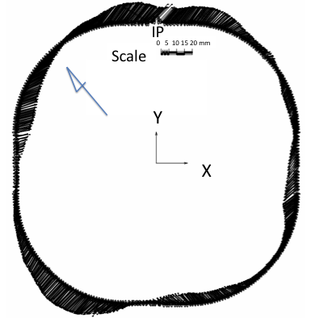
Figure 5: Deviation of the KEKB magnets from their design coordinates. The magnets follow a smooth curve, indicating that there was no large misalignment.
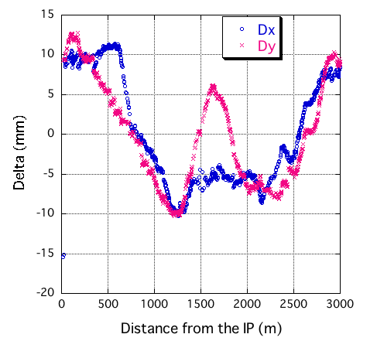
Figure 6: Deviation of the KEKB magnets from their design locations, plotted against the distance from the IP. The distance is measured counter-clockwise.
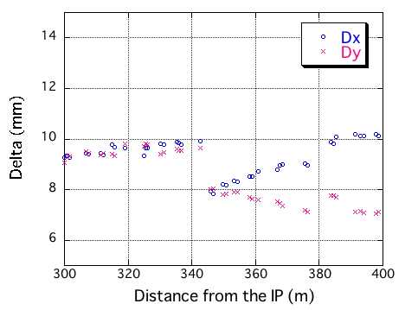
Figure 7: Deviations of the KEKB magnets located between 300 m and 400 m from the IP. A sudden change in deviation is seen at around 345 m.

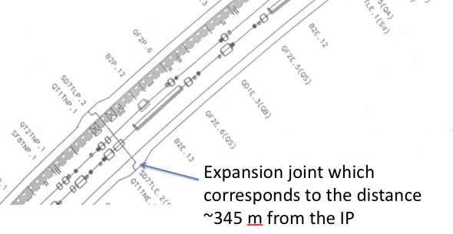
Figure 8: The expansion joint corresponding to the jump in Fig.7 is shown.

Test calculation with PANDA
We purchased another network software called PANDA (Program for Adjustment of Geodetic Networks and Deformation Analysis) from GEOTEC GmbH, Laatzen. The analysis is underway. The program has been modified by GEOTEC for us so that the laser tracker output files can be used without problem. It seems that there is no problem handling our large number of data points. The use of PANDA needs to be understood better, and this is one of the goals for this workshop. A very rough comparison is made between PAG-U and PANDA. A fairly good agreement is seen in the analysis in one direction (in this case, the “Y” direction) as seen in Fig. 9, though the agreement in X is not as good. An effort will be made to understand how to use this new program so that we can compare the two different programs.

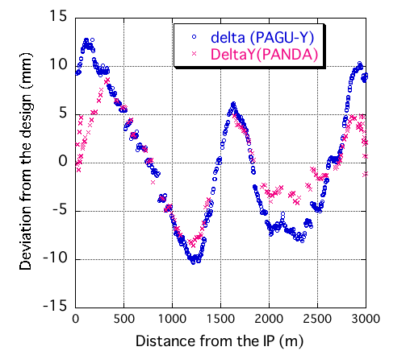
Figure 9: Initial comparison between PAG-U and PANDA results.

Tunnel level
The tunnel level survey was carried out during the summer of 2010. The monuments installed on the tunnel wall during KEKB construction were used for this survey. The tunnel level has been surveyed almost every year since the start of the KEKB commissioning. Figure 10 shows the tunnel survey results for the past ten years. The level with respect to the IP is plotted against the distance from the IP. The south arc section of the tunnel is seen to be sinking, at an average rate of 2.5 mm/year, though the rate seems to vary year to year. The reason why this particular part of the tunnel sinks is not known.

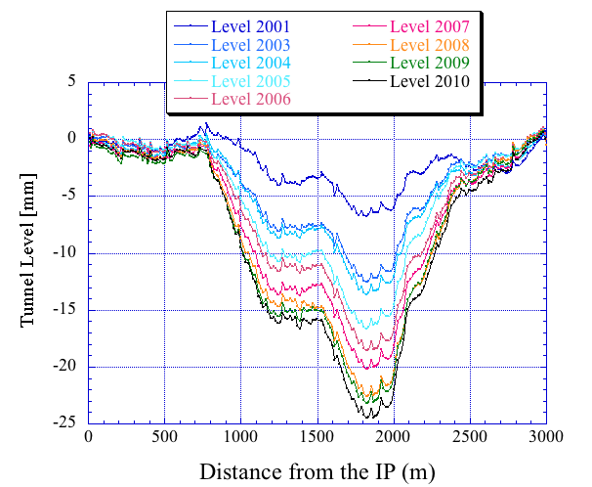
Figure 10: Tunnel level change over 10 years.

Summary and prospects
About 1300 new monuments were installed in the KEKB tunnel to construct a more complete survey network for the next-generation B-factory called SuperKEKB. A survey of the existing (not yet removed from the beam line) magnets and the new monuments was carried out using FARO ION laser trackers. Preliminary coordinates of the monuments were obtained.
This is the first time for us to build a network with such a large number of points, and time was required to become familiarized with the new FARO trackers and operation software (Insight). Issues to be pursued at this point are:

- The network at the IP needs to be improved.
- Re-measurements are needed for some tracker stations where the RMS of the fits to the design coordinates are much larger than expected.
- Independent analysis, for example via PANDA, would help in understanding the stability of the solutions.
- Another way of confirming the deformation is needed, such as via GPS. Reference points in the tunnel need to be transferred to the ground surface in order to use GPS. It is estimated that GPS has enough accuracy to verify the 20 mm distortions.

Questions that remain to be answered include how to use the network data for SuperKEKB when some magnets remain in the tunnel, and whether to re-level the beam line to compensate for the sinking of the tunnel, as was done for KEKB? In addition, the effect of the measured deformations on the emittance of the nano-beam lattice requires study by the optics group. We will continue working closely with the optics group on this issue.

References
[1] KEKB B-factory design report, KEK Report 95-7, August 1995.
[2] M. Masuzawa, “Next Generation B-factories”, Proceedings of the 1st International Particle Accelerator Conference (IPAC10), Kyoto, May 2010.
[3] Y. Ohsawa and M. Masuzawa, “Survey Monument Preparation for SuperKEKB”, Proceedings of the 10th International Workshop on Accelerator Alignment (IWAA 201), Hamburg, September 2010.
[4] R. Sugahara et al., “Installation and Alignment of KEKB Magnets”, Proceedings of the 6th International Workshop on Accelerator Alignment (IWAA 1999), Grenoble, October 1999.
[5] R. Sugahara et al., “Performance Test of Laser Trackers of FARO”, Proceedings of the 10th International Workshop on Accelerator Alignment (IWAA 201), Hamburg, September 2010.
[6] K. Mishima and A. Itano, “Survey and Alignment of the Medical Accelerator PATRO at HIBMC”, Proceedings of the 7th international Workshop on Accelerator Alignment (WAA2002), Nov. 2002, Spring-8, Japan.

