# **Talent man****agement for the Research Field Matter: Assessment and recommendations for the future**

As of: April 11, 2023

The working group was founded on behalf of the strategic advisory board of the Research Field Matter in the Helmholtz Association and consists of personnel management, personnel developers and scientists from a total of seven Helmholtz centres (see annex 1).

Under the leadership of Katja Frerks (DESY) and Jennifer Schevardo (HZB); as from September 2021, the working group met seven times and jointly developed a paper to be presented here.

The working group is based on the agreement between funding authorities and the Research Field Matter centres in the research policy aims, to report within a period of two years about the status of talent management and to discuss this report on the Research Field Matter platform.

The Research Field Matter also pursues the goal to train or recruit the best talents from all over the world. Programs for the recruitment and promotion of young scientists and the expansion of attractive career perspectives contribute to this in the same way as central measures to improve the reconciliation of private and professional life. This should also include the fascination of pupils at an early stage for MINT subjects. Within the research policy aims, there was an agreement between funding authorities and Research Field Matter centres that Research Field Matter talent management – embedded in the corresponding strategies of the Helmholtz Association – has to be further developed and extended on all levels.

## Talent management for the Research Field Matter – what exactly does it mean?

Talent management is a widespread term but it is often used in an unspecific way. Usually, talent management is understood as recruiting, holding and promoting qualified employees. The aim of a holistic personnel strategy should be to staff all relevant positions within the own organisation in a timely manner, for long terms and with qualified talents.[1]

The themes addressed in the research policy aims may be regarded in terms of the common practice in the Helmholtz centres on the handling of talent management within the context of the employee lifecycle[2]. This enables a differentiated view on different occupational groups and career phases. The employee lifecycle defined by the working group consists of the following eight phases:

|  |  |  |
| --- | --- | --- |
|  | **Attraction:**  **Recruitment:**  **Onboarding:**  **Task planning:**  **Development:**  **Controlling:**  **Succession planning:**  **Exit:** | *Design centre / Helmholtz brand*  *Hire employees for all tasks*  *Professional welcome & training period*  *Clarify responsibilities*  *Open up vertical / horizontal career paths*  *Structured personnel data acquisition*  *Targeted filling of vacant positions*  *Farewell / knowledge transfer* |

This view may be applied to strengthen the occupational groups employed in the centres in their development phases against the background of the research policy aims.

The definition developed by the working group takes into account the specific conditions of the Research Field Matter as well as the resultant requirements on the current and future employees of the centres concerned.

In the Research Field Matter, target groups of talent management are the current and potential employees of all **occupational groups**, their good collaboration being of key importance. The talent management is **strategically** targeted to the **research policy aims** of the research field in PoF IV:

1. **Development, construction und usage of cutting-edge large-scale facilities**:

It is necessary to recruit and retain large numbers people with a specific expertise to operate the facilities. Hence, a special focus should be put on personnel marketing and employer positioning. There is a great demand for qualified employees across the labour market. Specialists are in great demand thus having many choices in their search for a job.

To make research institutions with its existing remuneration possibilities attractive for scientific, technical and administrative specialists or IT experts, talent management must develop and realise effective incentives.

1. **Joint forces in international networks and recruitment of the best talents in international competition**

The centres cooperate in many ways; however, they compete with each other for the best international talents as well. In this context, it is also important that employers implement diversity within their own organisation. Only an employer who roots diversity as an integral element of corporate culture remains competitive today in the international context.

Moreover, a special concern is to increase the percentage of women especially in the occupational groups of science, technology and IT.

The aim of numerous talent management measures is to increase the number of international employees and to fully exploit potentials. As a result, this offers the possibility to create, develop and relink various international networks.

1. **Offer of excellent development possibilities and long-term career paths for all employees**

**3 a) Science**  
In the research field; currently, development perspectives and career options are predominantly aimed at scientific personnel. For this purpose, the centres implemented measures to serve the specific needs of the Research Field Matter which is exemplarily illustrated below.  
Cooperation with universities and in part with business and industry facilitate additional career options. The Helmholtz Association and its centres see their responsibility in providing the best possible qualification and counselling for their temporary employees to allow for promising follow-up careers, possibly also beyond science. The alumni who were given this opportunity secure promising networks and cooperations for a long-term.

**3 b) Technology task sectors, IT, administration, infrastructure sectors**There are hardly any specific measures for other occupational groups; therefore, this paper will move them into focus. Particularly for the operation of large-scale facilities that are important for the Research Field Matter, which are partly operated day and night and are made available to external partners, these occupational groups are essential.

1. **Strengthening of science and technology transfer into non-scientific sectors**

As a result, talent management has the task to recruit competent people or develop the competences of active employees. Moreover, the offers of the centres to alumni play an important role, as they may be important external cooperation partners.

1. **Promoting young talents for STEM themes**

The final important goal in the Research Field Matter is the clear effort to fascinate young talents at home and abroad for STEM subjects or tasks and to attract them especially for a possible future occupation in the research field – as apprentices, students, doctoral students or postdocs. A basic knowledge of STEM subjects is essential for scientific jobs and for many kinds of supporting work for the (further) development, construction, operation and usage of large-scale infrastructure facilities.

## Talent management for matter – where does the research field stand at large?

In the following critical assessment of the centres in the field of talent management, all activities and offers have been compiled in consideration of the employee lifecycle (see annex 2). Activities and measures are presented that are based on concepts and can be linked to target groups and/or career phases. In this way, a contribution is made to the development of talent management in the entire organization - independent of individual interests or actions. As a rule, these measures have been negotiated with work councils, as they can have an impact on career development.

In a summary, the analysis of activities in the research field shows:

* There are various general offers and services, e.g. centre-internal education programs, welcome offices, etc. which are available to all employees. Focus areas are: recruiting, onboarding, development.
* Recruiting and development of scientific young talents and of scientific personnel take centre stage in specific activities within the research field.
* There are a small number of measures that are specific to the Research Field Matter (they are highlighted in yellow in the annex).
* In **multi-thematic** oriented centres, many of these measures in talent management are implemented **in all research fields** – not only in matter.
* Special measures for employees in administration, infrastructure and technically qualified personnel, engineers and IT experts exist only in individual cases.

In the following chart, the activities of the centres for individual target groups are allocated to the employee lifecycle. The schematic representation shows both, the concentration of the already existing (partly research field specific) activities and the gaps in the offering structure until now.

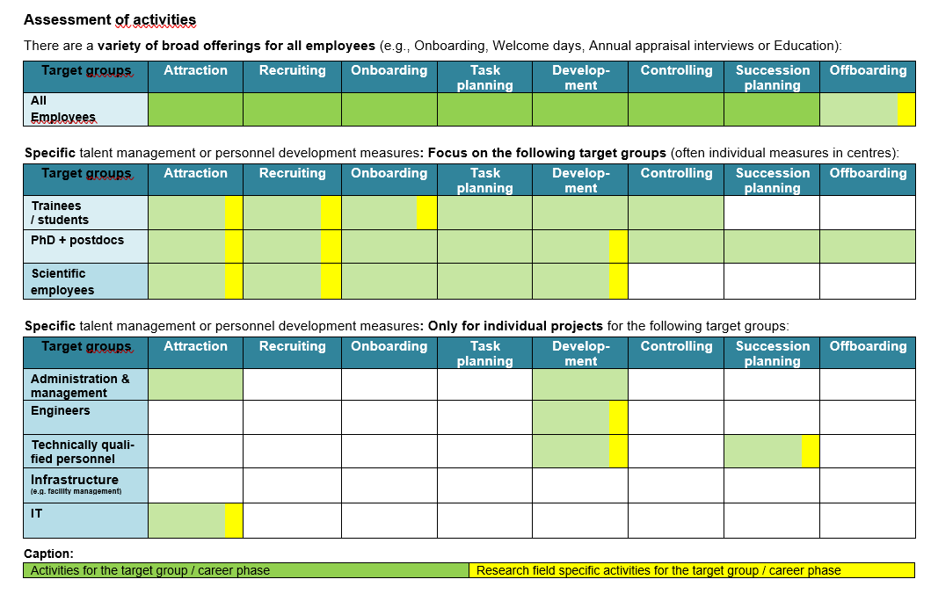

It can be seen that there are only a small number of specific measures for the various target groups and career phases. Measures related to the research area of matter are an exception. The overall focus of the measures is on the scientific areas. Measures for technical staff or IT are rare exceptions.

## Talent management for Matter – specific activities of the Research Field Matter

In the following sections, the research policy goals are related to existing measures in the centres, which in each individual case are not explicitly Research Field Matter-oriented. Many of the measures described here are only applied in particular centres.

The financial and personnel resources available for the talent management theme differ to a great extent in the individual centres.

In view of the complete research field; how are the central challenges already being addressed? A choice of individual suitable beacon projects will be presented here.

### **Attract and retain the best talents for the development, construction und usage of cutting-edge large-scale facilities („Recruitment“ phase)**

Large-scale facilities require a very specific or specialised technical expertise which in very few cases the technical experts, engineers and IT experts are already familiar with. The qualification for highly specialised tasks is obtained via training in practice, transfer of technical expertise and with the help of specific training.

In many cases, the centres offer jobs with a high potential of creative and independent work; this is frequently not known by trainees and students.

Through currently existing dual study paths, young talents may be trained in and retained for the specific requirements of the centre already in the course of their study.

Moreover, it is important that the centres present themselves as employers with information events at technical universities of applied science and universities. Examples of measures to attract pupils for vocational training or dual studies are illustrated below.

**DESY: Virtual event to attract female engineers**

|  |  |
| --- | --- |
|  | **University marketing**   * Target group of the 1.5 hour virtual event: * **Female students** of northern German **universities of applied sciences and technical universities** * Program: * Welcome address by DESY director * Short film about DESY‘s research goals * **Female engineers** introduce themselves as **role model** and discuss in breakout sessions * Presentation of benefits of the employer |

Conclusion:

It is important to effectively communicate the attractiveness of positions and tasks in the field of technology and IT for the recruitment of personnel.

It should be examined whether this format can be extended to male students as well.

### **Promote international networking and competition with diversity and internationalisation („Attraction“ phase):**

There are programs in the centres which are specifically aimed at the Research Field Matter and which explicitly promote young scientists. All centres are internationally cross-linked through cooperation in science. So far, these networks have not been systematically used within the context of talent management.

The **Tasso Springer Fellowship Program** was conceived by Forschungszentrum Jülich and it offers fellowships to PhD’s and postdocs in the field of neutron(scattering).

<https://www.fz-juelich.de/en/jcns/careers/fellowships/tasso-springer-fellowship-program>

**Forschungzentrum Jülich / Hereon: GNeuS**

Jointly with Technical University of Munich (TUM), Forschungszentrum Jülich (FZJ) and Hereon raised funds from Horizon 2020 for the project **GNeuS** (Global Neutron Scientists) of the Marie Sklodowska-Curie Actions program. The EU funds this project over a period of five years with over 3.3 million euros. The three leading partners invest another 5 million euros. Together with 19 additional partners, TUM, FZJ and Hereon want to ensure that also in the future the potential insights of neutron methods will be used in the best possible way by training a new generation of excellent neutron scientists. Within the framework of the project; for the first time, 45 postdocs are offered to go through a 24-month structured, interdisciplinary and intersectoral global training program. Moreover, the program is interlinked with the InnovaXN project which since 2019 successfully provides a structured training for PhD’s

<https://gneus.eu/>

**KIT: Helmholtz International Research School for Astroparticle Physics and Enabling Technologies (HIRSAP)**

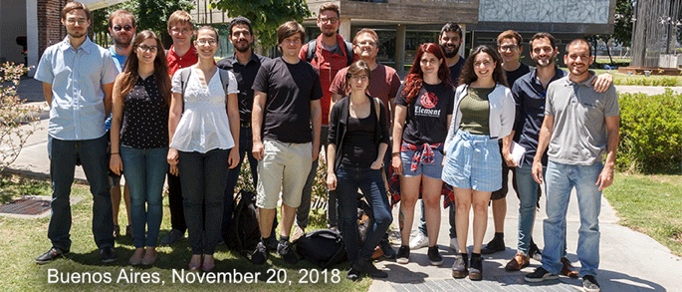HIRSAP is a graduate school of the Karlsruhe Institute of Technology (KIT) and Universidad Nacional de San Martín (UNSAM) which was established in April 2018. It is dedicated to the development and application of cutting-edge particle detection techniques and corresponding analysis methods in high-energy astroparticle physics. The school has a very international and interdisciplinary character by bringing together leading physicists and engineers that come from different continents. There is a double doctoral degree agreement in astrophysics and electrical engineering that exists within the framework of the school. <https://www.hirsap.org/>

Conclusion:

In principle, it is feasible to extend the two existing programs to other centres. Possibly, it will be convenient to set up new cooperations or comparable programs regarding other themes. Scientific personnel is currently in the focus of these measures.

In connection with administration and also referring to the technical personnel, it is feasible to develop additional programs promoting diversity and globalization.

### **Develop and promote career perspectives („Development“ phase):**

In their career orientation, postdocs encounter new professional support in the career centres provided by the Helmholtz Association.

## Moreover, there are mentoring programs in the centres which promote excellent (female) young scientists and help to clarify career perspectives in the field of science and outside of science. In consideration of the still low proportion of women – some 25 percent – in the research fields of science, many programs are particularly aimed at women. This makes sense because in total the proportion of women is low within the Research Field Matter.

## For many years, the Helmholtz Association promotes the acquisition of excellent female scientists with the programs „Funding of first-time professorial appointments of highly talented female scientists (W2/W3)“ and „Supporting the recruitment of top international women scientists (W3)“.

## There are other specific programs in the centres for women who want to orient themselves towards a career on managerial level.

**KIT: Women on management level: female professor programs**

The **100 professorship program** has set the ambitious goal to staff 40 percent of new professorial appointments with female professors, thus reaching a proportion of women of 20 percent among the university teachers until 2030. As from 2017, the proportion of women accepting a call increased from 20 percent to 34.5 percent in 2021, so that KIT is well on the way to fulfill the 20 percent goal (16.4 in 2021). In order to more effectively address gender aspects in the appointments committee, an **online module to expand gender competence** was developed and participation is compulsory for members of the appointments committee.

**Recruiting of university teachers** is facilitated in the ExU project Gender Equity 2 (GE2) by providing an additional appointment budget explicitly to win outstanding female professors. Since the beginning of the project in 2019, seven female university teachers have been supported at KIT with a total of 1,227,000€. In addition to this, a **Female Academics Network** (FAN) has been established in GE 2 which will link female scientists from KIT with national and international partners and alumni from research, teaching and innovation with lecture series, mentoring and research stays, and strengthen the visibility of particularly young female scientists. There are plans for close collaboration with the **Women Professors Forum** (WPF) at KIT. WPF was started in 2021 by women professors of KIT; among others with the goal to further enhance the visibility of excellent women scientists and to build networks among them. [Women Professors Forum](https://www.wpf.kit.edu/index.php" \o "https://www.wpf.kit.edu/index.php)

Conclusion:

The above illustrated programs aim at increasing the proportion of women in science at large and in leading positions. In this occupation, the women scientists exert an exemplary function as role models.

The career centres of the Helmholtz Association aim at accompanying and promoting postdocs in their career paths in and outside of research – at home and abroad.

It is remarkable that also in this topic area the focus is currently on science. Mentoring programs to support women are feasible in technical sectors or IT as well. This is also true for career paths. It is conceivable to qualify technical personnel in a targeted way within the centres in order to provide development perspectives to interested employees and thus retaining them in the centres.

### **Strengthening of knowledge and technology transfer to non-scientific areas („Development“ phase):**

The transfer of knowledge and technology is carried out in many ways in the centres.

For one thing, the goal is to communicate the relevance of research to the outside world. At the same time, it offers development possibilities when employees get the opportunity to try out ideas within the framework of startups.

Conclusion:Technology and knowledge transfer are politically intended and an important research policy objective. The focus of this objective is on career development via external cooperation. It would also be important to think about how to retain and develop particularly employees with a very specific specialist expertise.

### **Fascinating young talents at home and abroad for MINT subjects („Attraction” & Recruitment“ phases):**

In this topic area, many centres are active. MINT days are offered to girls, pupils may get an insight in research in laboratories, especially designed for them. All centres participate in the annual Future Day (former Girls’ & Boys’ Day) and offer special activities for schools.

At many centres, the participation at vocational training fairs is a regular standard as well as the participation in Physics Olympiads or other school competitions.

**DESY: since 2019 cooperation with CERN: „Beamline for Schools“**

Beamline for Schools (BL4S) is a physics competition initiated in 2014, open to high-school students from all around the world. The participants are invited to propose a scientific experiment that they want to perform using the beamline at particle accelerators at DESY and CERN. Here, scientists do experiments in various fields spanning fundamental physics, medicine and materials science. As from 2019, DESY provides beamline time to a high-school team of two students (three teams since 2022). The high quality of the winning proposals shows that, with the right support, high-school students can tackle complex modern physics topics and fully develop a research plan.

Beamline for Schools is an education and outreach project funded by the CERN & Society Foundation and supported by individual donors, foundations and companies.

Link: [Beamline for schools](https://beamlineforschools.cern/)

**HZDR: „Summer of Science of the HZDR DeltaX School Lab**

This summer becomes scientific! The DeltaX School Lab starts into the Summer of Science. From the first until the last day of summer holidays, the school lab at Helmholtz-Zentrum Dresden-Rossendorf (HZDR) offers a diversified and eventful program covering themes from biology, chemistry, physics and astronomy. The holiday offer addresses pupils hungry for knowledge of all ages ranging from 9 years to secondary-level.

Conclusion:

The participation in MINT activities is important since it include a great potential to win interested talents for training places and dual studies.

It would be conceivable to link activities across the centres and to create other attractions for young people.

## Talent management for the Research Field Matter: Potential measures for target groups in technical areas which up to now are (far) too little in the centre of attention

The analysis of activities in the centres shows that there is a need across the centres to increasingly promote technical professions on all career levels.

The current labour market situation is characterised by competition for qualified technical personnel since altogether there is a lack of technical personnel in Germany. We speak of an **“employee market”** meaning that the employees are able to choose their employer and not vice versa. Business enterprises are glad to recruit the often very well trained employees of Helmholtz centres.

**Additional challenges for Helmholtz centres are:**

* Salary structures of the centres, etc. are below salaries of free enterprises
* Helmholtz centres provide high-quality training in technical professions. However, many centres guarantee only a temporary job for half a year to their trainees or a temporary follow-up contract for 1 – 2 years.
* Continued employment after training would be efficient and target-oriented, but often fails due to a lack of open positions and/or financial resources in the individual centres.

As a result, the Helmholtz Association loses motivated and well trained specialists. This is a fact that not all leaders and scientists seem to realise.

All centres offer dual studies in collaboration with universities or universities of applied sciences in local areas (see overview in annex 3). This is one of many advantages which centres have already now to recruit and develop technical talents. Other possibilities are described in the following graphics. The working group proposes to focus on technical personnel and implement a new support program for this target group. At the same time, the costs should be evaluated in relation to the benefit of this measure. As the centres already pursue comprehensive strategies which bind the specifically employed personnel as well, additional funding resources are necessary for a new program.

1. **Proposal**: Measures to recruit, retain & develop technically qualified personnel

The working group suggests to envisage the following measures which may be extended by additional ideas and approaches:

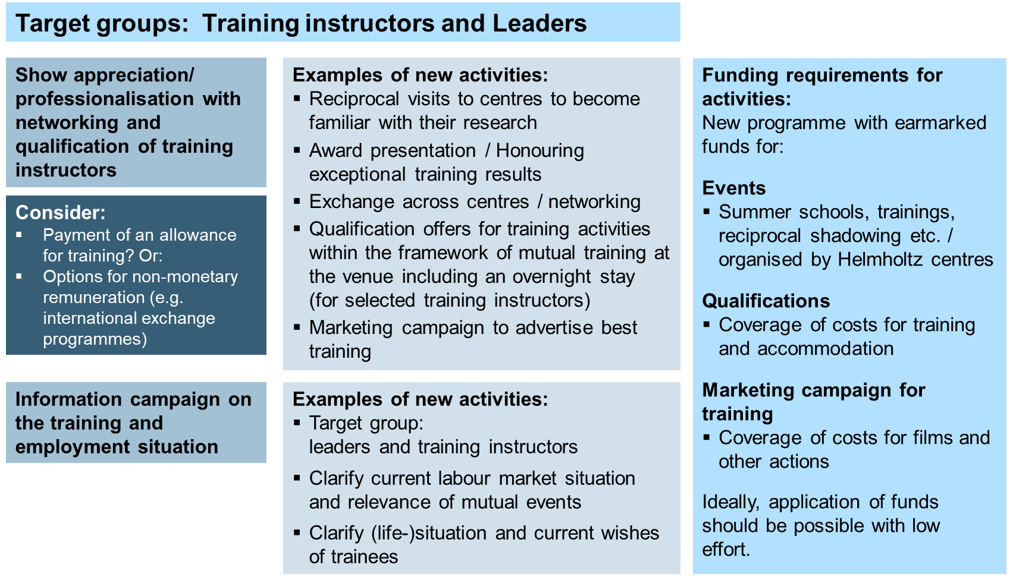

**The above mentioned measures are directed to the following three levels**:

* Recruit and retain technically qualified personnel
* Further qualification of qualified personnel who do not wish to study
* Development perspective for best trainees interested in dual studies

Moreover, it is important to focus on leaders and trainers as well. They play a key role in the implementation of talent management for these target groups.

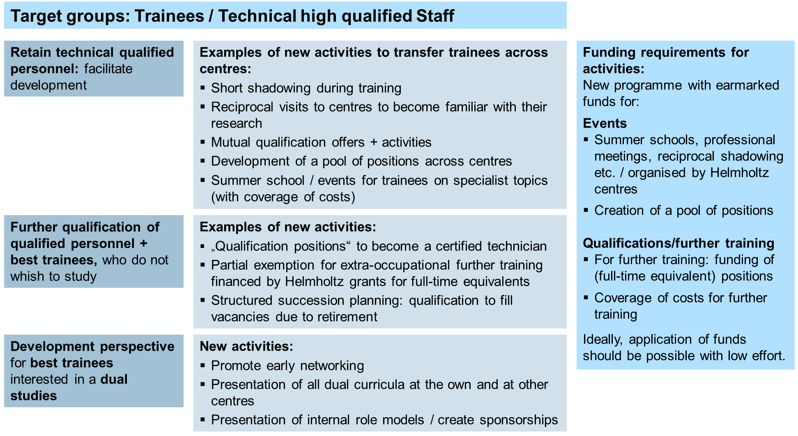

The goal is that centres are able to join forces for the implementation and to develop common measures according to their own needs. For the implementation, they can apply for material costs from a new financing pool which is to be created.

It should be examined whether this program may be extended **to all research areas of the participating centres**, as an “artificial separation” on the organizational level is hardly possible. As a rule, the technical personnel is deployed in more than one research area in **multi-thematic** oriented centres.

In annex 4, the measures are related to goal settings, range and financial scope.

**Advantages of such an approach:**

* Helmholtz binds talents to its own centres.
* No costs and time-consuming selection procedures.
* Internal career perspectives are created through the development of career paths for technically qualified personnel.
* A target group is moved into focus which is of central importance for the Research Field Matter
* The Helmholtz Association is asked to organize an event in Berlin for the appreciation of technical personnel
* Already existing and currently piloted measures are better networked and increase their potential

1. Final Conclusion: A specific field of action is identified.

Some of the proposed activities and measures can be organized by the centres themselves, others with support of the Helmholtz Association.

**Additional support is required:**

* for cost-intensive HR development measures - also to be able to compete with free enterprises in the working market
* Joint activities of centers strengthen the recruitment and retaining of qualified technical personnel
* (temporary) resources in the HR groups to organize future measures

With this paper and the developed proposal, the Research Field Matter is given the opportunity to develop new focus in the area of talent management based on the research policy goals of PoF IV.

The working group would appreciate the support in the implementation of the research policy goals of PoF IV and the additional funding of resources for these tasks.

1. Following the definition at: https://www.personio.com/hr-lexicon/talent-management/
2. https://hr-universal.de/en/hr-universal-hr-consulting-and-personnel-brokerage/