**Naming and numbering CALICE sensors at TAU**

1. Sensor numbering

Each sensor will have an identification number (ID). This ID will be coded with three numbers and starts from #001.

This ID also will associate with the S/N which will come from HAMAMATSU.

In case of batches arrival, the arrival batch date will be added to the ID, after a "_". Hence, the new ID will be like: #XXX_DDMMYY

While #XXX is showing the sensor identification number.

If all the sensors arrive in one batch, the date will not be added to the ID.

1. Pads numbering

The sensor should be oriented in such way the “F” letter (etched on the sensor) will be located on the bottom right side.

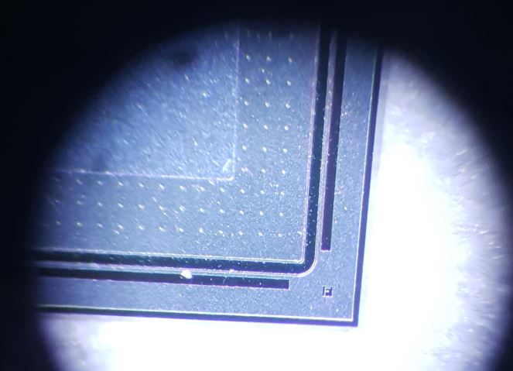

Each sensor consists of 16 rows x 16 columns in a total of 256 pads. Each pad will be referred by two numbers x and y, respectively the row and the column. These two numbers will start from one and will be grouped as (x,y).

For example, the first pad will be located at (1,1) and the last pad of the first row will be labeled as (1,16).

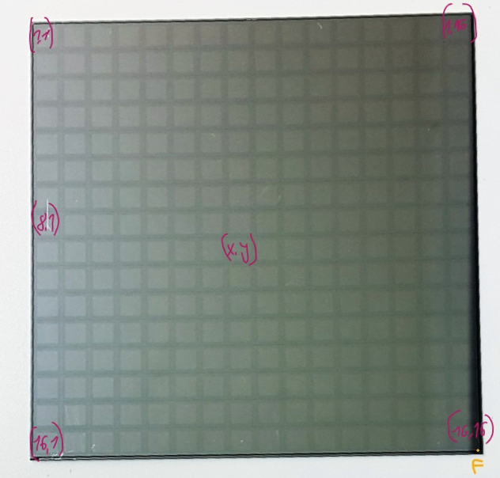

(15,5)

(15,0)

(0,15)

(7,8)

(15,15)

(0,7)

(0,0)

Here a photo illustrating the location of each pad on the sensor.

1. IV/CV test results

After the sensor IV (or CV) measurement, there are three output files: two pictures and one text file (with raw data).

The folder hierarchy will follow:

* Sensor_measurement
  + Sensor ID
    - IV results
    - CV results

It might will be more than one test for IV or CV for the same sensor this will be kept in a file as IV_test-0_#XXX_DDMMYY and

IV_test-1_#XXX_DDMMYY or CV_test-0_#XXX_DDMMYY and

CV_test-1_#XXX_DDMMYY.

It might will be other file that contain comments about the sensor or pads (x,y) in the sensor etc. the file name will be IV_#XXX_DDMMYY_(x,y) or CV_#XXX_DDMMYY_(x,y).

The quality of the sensor will be indicated by a green (red) sticker on the sensor box for good (bad) sensor.

Pad summary: number of faulty pads will be indicated on the sticker, and the pad list will be in the excel file under pad status.

Sticker will look like this:

|  |  |  |  |  |  |
| --- | --- | --- | --- | --- | --- |
| **Sensor ID** | **QC arrival** | **IV result** | **CV result** | **#faulty pads** | **Sensor Q** |
|  |  |  |  |  |  |

The sensor status will be in an excel file, example of the file below.

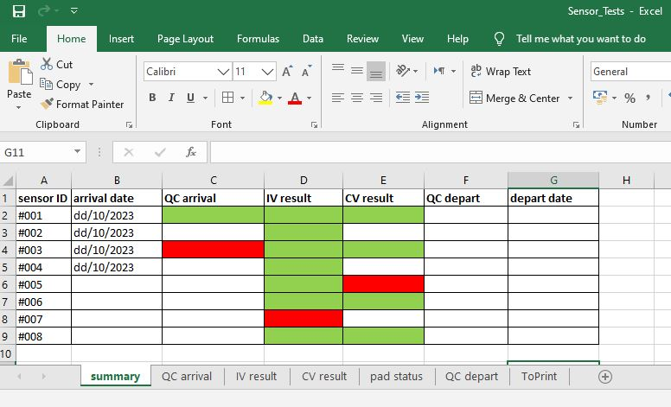

QC arrival: physical state, in what status the sensor arrived to TAU,

green = very good, red= bad condition (scratched).

With the work we will change or add appropriate factors.

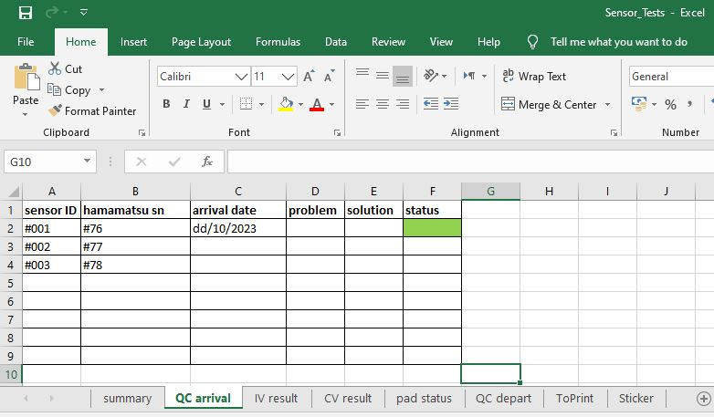

Sensor ID associated with the HAMAMATSU S/N

With the work we will change or add appropriate factors.

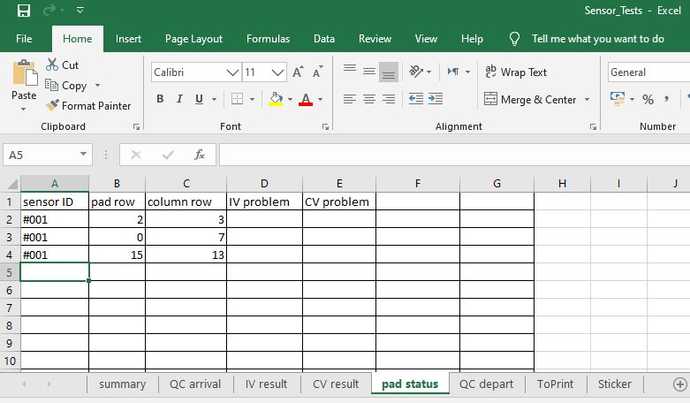

Pad status: sensor ID associated with the (x, y) problems with IV or CV measurements.

All the information and details we will be collected about the sensors and will be gathered in the Excel file, and the IV and CV files, all of these will be accessible online on our *FCAL* webpage *https://www.fcal.desy.de*

under *LUXE construction* which is divided according to TAU sensors, IFIC sensors, Kraków sensors and Warsaw sensors, important details for each sensor according to its ID will be displayed.

