Research Field *Matter*

**Strategy Paper**

*[Notes: This paper outlines the status of the strategy for PoF V and it will be part of the discussion during the scientific evaluation 2025. It will be included in the status report: the first two sections at the beginning, the remaining sections as the outlook of the research field.*

*Please follow the corporate design of the Helmholtz Association and use standardized language (see glossary).]*

*The document should not exceed 10 pages*

*Editorial remarks of RF Matter are highlighted in yellow.*

Involved Helmholtz Centers:

1. Name
2. Name
3. Name
4. Name

*To facilitate the use of the template, you will find short explanations or guiding questions (highlighted in yellow. Please delete them completely before submitting this report.*

*Please use: American English Language, Font Arial 10, Line spacing 13 Pt.; Paragraph spacing 6 Pt. The page margins must be 2.5 cm at the top, left and right, and at least 2.0 cm at the bottom.*

*If possible, please refrain from using the usual Helmholtz terms and abbreviations in this document. Please write in more general terms for a (scientific specialist) audience that is not necessarily familiar with Helmholtz.*

Content

1 Research field Matter and its current research portfolio 1

2 National and international context 2

3 Challenges for the next ten years 2

4 Mission and research objectives 3

5 Future thematic and programmatic positioning 4

5.1 Scientific positioning 4

5.2 Structure of the research field 5

5.3 Role of infrastructures in the research field 5

5.4 Internal and external cooperation 6

5.5 Cross-cutting topics 6

5.6 Commitment to strengthening and advancing our workforce and infrastructures 7

6 Annex 8

Excerpt from the Verfahrenspapier:

Die als Ergebnisse des Strategieprozesses vorzulegenden Strategiepapiere sollen der folgenden für alle Forschungsbereiche gemeinsamen Gliederung folgen:Aktuelles Forschungsportfolio

* Einordnung in den nationalen und internationalen Kontext
* Herausforderungen der nächsten 10 Jahre
* Mission und Forschungsziele des Forschungsbereichs
* Zukünftige thematische und programmatische Aufstellung
  + Wissenschaftlich-programmatische Ausrichtung
  + Struktur des Forschungsbereichs
  + Rolle der Infrastrukturen im Forschungsbereich
  + Kooperationsstrategien (intern / extern)
  + Strategien zu programm- und FB-übergreifenden Themen wie z.B. Digitalisierung
  + Strategien zu zentrenbezogenen (forschungs-)politischen und/oder strukturellen Themen wie z.B. Innovation und Transfer / Talentmanagement, Nachhaltigkeit, Parität (Chancengerechtigkeit), Diversität, Digitalisierung,

1. Research field Matter and its current research portfolio

1 page

Introduction to Research Field Matter & current research portfolio (this will probably also address the current strategic objectives to some extent)

Optional (if there’s enough space): Figure/Table with centers and LK II, see example from last strategy paper below

Input: CB and programs

Coordinator: Research Field coordinator

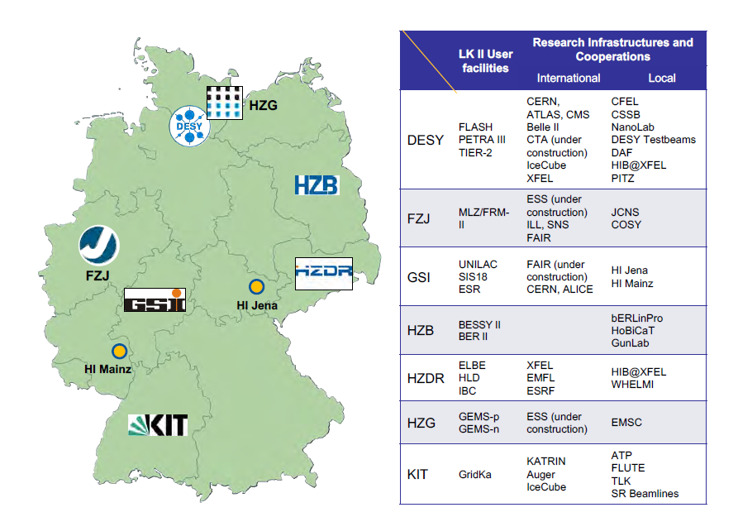

[Text]

1. National and international context

½ pages

Input: CB and programs

Coordinator: Research Field coordinator

[Text]

1. Challenges for the next ten years

1 page

1/3 page introduction of the Research Field followed by approx. 9 major scientific challenges & technological questions.

The three programs should be in close exchange to fine-tune the level of detail of the questions/challenges and ensure that a diverse picture of the Research Field is be shown here. In addition, the overarching Matter-perspective should always be considered (the questions/challenges could at best relate to the “grand challenges” of the Research Field Matter in a way).

Input: Programs

Coordinator: Programs

Aus dem Protokoll der MB-Sitzung am 13.12.2023: “Gesellschaftliche Herausforderungen darstellen und nicht nur auf (mögliche neue) Großgeräte verweisen”

[Text]

1. Mission and research objectives

1 page

Research Field and programs each 1/4 page

Focus on overarching, long-term strategic mission/objectives (to better separate from chapter 5)

Input: Programs

Coordinator: Research Field coordinator

Aus dem Protokoll der MB-Sitzung am 13.12.2023: “Antworten auf die in Kapitel 3 formulierten Herausforderungen geben“

[Text]

1. Future thematic and programmatic positioning

Brief (2-4 lines) introductory text to this section.

[Text]

* 1. Scientific positioning

3 pages

Each program 1 page

Input: Programs

Coordinator: Research Field coordinator

[Text]

* 1. Structure of the research field

½ pages

Short introduction followed by a figure/table with program and topic structure (incl. LK II), see example below (it would probably be good to use a figure without percentage numbers)

Input: CB

Coordinator: Research Field coordinator

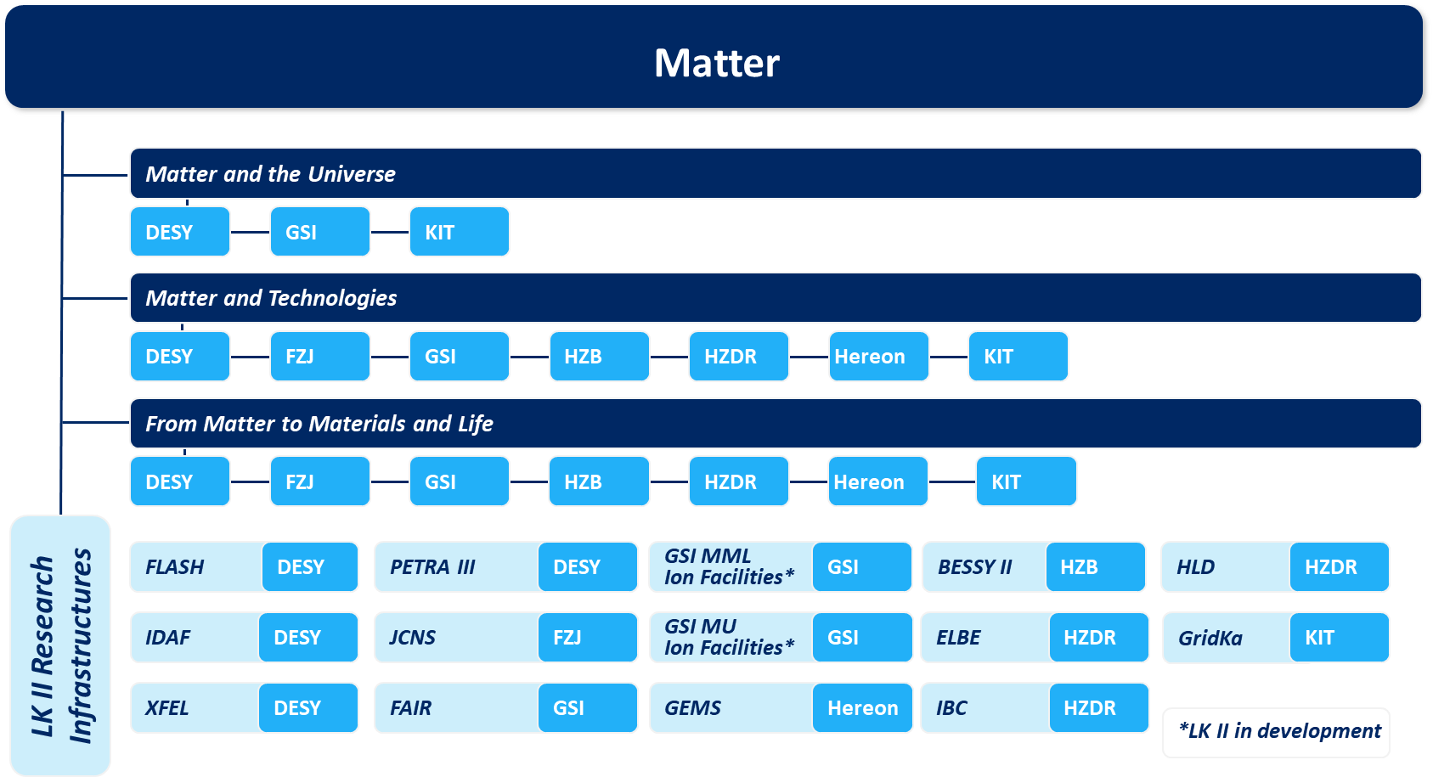

[Text]

* 1. Role of infrastructures in the research field

½ pages

Please do not name and list all infrastructures. Only describe the general importance of our different groups of infrastructures (e.g., computing centers, photon sources, neutron sources, etc.), LK I, LK II as well as the large international infrastructures which are essential especially for MU (e.g. CTA, Auger, KATRIN…). Please also focus on the many (national and international) users from universities and other research centers who use the infrastructures and services provided.

Input: Programs

Coordinator: Research Field coordinator

[Text]

* 1. Internal and external cooperation

½ pages

The three programs should work closely together here to avoid writing the same and to present a complete and clear picture. Some examples could be very helpful.

Input: Programs

Coordinator: Research Field coordinator

Aus dem Protokoll der MB-Sitzung am 13.12.2023: “Neben der externen Kooperationsstrategie auch darstellen, warum die drei Programme MU, MT, und MML im FB Materie gemeinsam verortet sind”

[Text]

* 1. Cross-cutting topics

½ pages

Input: Coordinators of Helmholtz Quantum (n.n.) and Helmholtz Climate (Matthias Rehahn)

Coordinator: Research Field coordinator

Aus dem Protokoll der MB-Sitzung am 13.12.2023: “Beschreibung der beiden Helmholtz-weiten Querschnittsthemen Quantum und Klima mit Fokus auf die Schnittstellen zu anderen”

[Text]

* 1. Commitment to strengthening and advancing our workforce and infrastructures

1,5 pages

Strategies on center-related (research) policy and/or structural topics such as innovation and transfer, talent management, sustainability, parity (equal opportunities), diversity, digitalization, etc.

A list of all centers and their activities should be avoided. Rather general (and Research Field-wide) aspects could be described first, which are then substantiated with one or two best-practice examples.

The centers should be in close exchange to fine-tune the examples and ensure that a diverse picture of the activities of the centers of the Research Field is be shown here. In addition, the overarching Matter-perspective should always be considered (and could at best relate to the “grand challenges” of the Research Field Matter in a way).

Input: CB and working groups Transfer & Public Relations, Sustainability and Gender Equality

Coordinator: Research Field coordinator

[Text]

1. Annex

Table of all LK II and associated infrastructures (European XFEL and FAIR) including names, acronyms, centers involved and description of each LK II in one sentence

Optional: key figures on size, resources or users (under discussion)

Input: CB

Coordinator: Harald Buddeweg