**Points to discuss**

* Ø6 mm tab in T-frame
  + CNC milling (not turning)
  + In presentation (powerpoint) with name “ECAL-P_tungsten_and_1st_T-frame-MAY-2024_s_v2” there is a g6 tolerance. Is this ok? How do you plan to get the g6 tolerance with CNC milling?
  + If not, what is the tolerance for the tab?

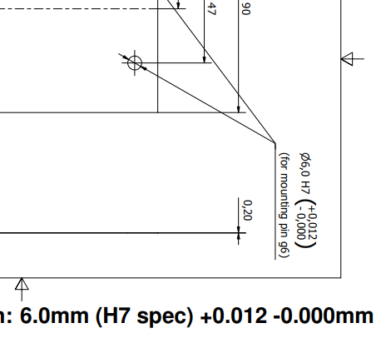

ECAL-P_tungsten_and_1st_T-frame-MAY-2024_s_v2

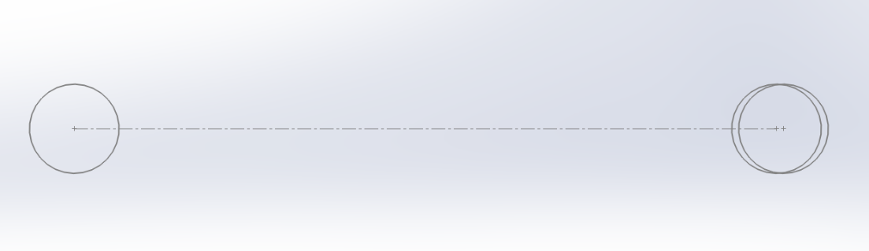

* Need for detailed sensor assembly drawings to drive design of the components of the sensor.

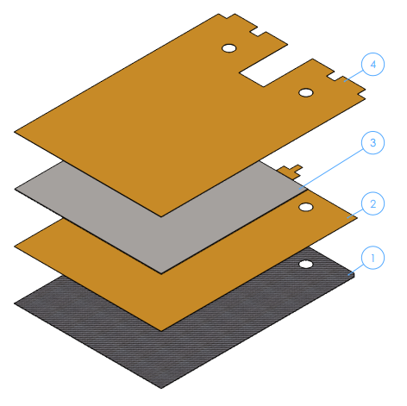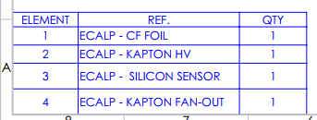

* Define naming of the components of the sensor:
  + - 91. Si_sensor_kapton_CF
      * 91.1 Si sensor
      * 91.3 CF
      * FanoutSignalBend
      * FanoutHVBend
* Documentation traceability. Where can we get the latest version of the 3D model? How can we know which is the latest accepted version?
* Specification of component tolerances to design inspection jigs and drive CMM inspections. Lack of acceptance criteria.
  + Show our drawings.
    - ECALP - CF FOIL INSPECTION JIG
    - ECALP - INSPECTION JIG ASSEMBLY_Rev0

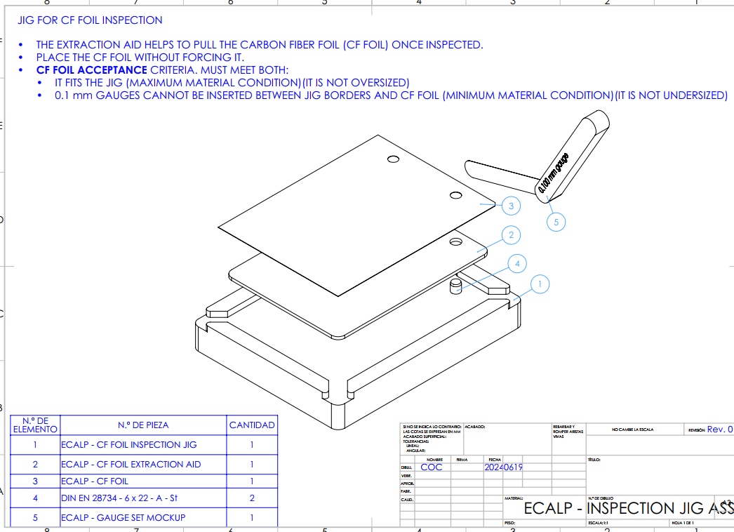

**Drawings:**

* ECALP - SENSOR ASSEMBLY_rev0
* ECALP - CF FOIL INSPECTION JIG
  + ECALP - INSPECTION JIG ASSEMBLY_Rev0