Diversity is a strategic necessity for the future of particle physics, because it enhances innovation, broadens perspectives, attracts and retains the best talents globally, and improves decision-making [[1],[2],[3],[4],[5],[6]].

As stated in the European Strategy for Particle Physics 2020 Update “The particle physics community commits to placing the principles of equality, diversity and inclusion at the heart of all its activities.” For the current update of the ESPP we propose to extend this statement with a commitment of the community to implement target-based and leadership-led strategies to actively improve and check diversity benchmarks across the different dimensions of diversity.

Diversity dimensions are the social background, age, ethnic background and nationality, gender and gender identity, physical and mental abilities, religion and world view and sexual orientation as outlined in [[7]]. In this context it is also needed to consider outer (like for example care responsibilities, family status, etc) and organizational dimensions an individual is placed in as shown in Figure 1.

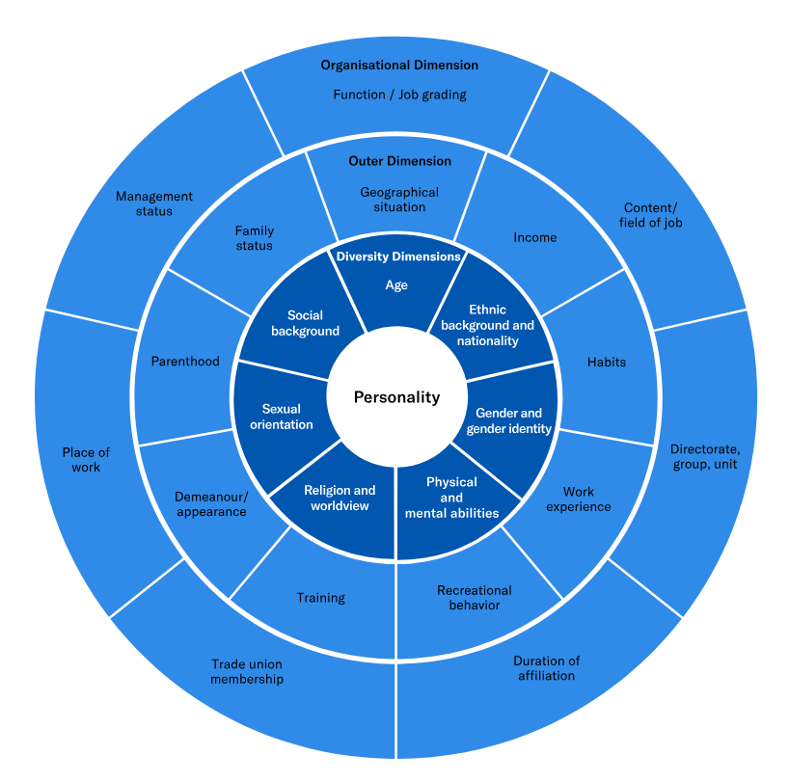

Figure 1: Diversity dimensions of the "Charta der Vielfalt” [7].

At the same time our community stands for promoting scientific collaboration across borders, inclusiveness and open science, transcending political and other conflicts as stated in CERN’s main objectives document [[8]]. We have the unique opportunity as a global, highly innovative, respected and influential research community, to advocate for policies that promote diversity and inclusion on societal level in e.g. education, research, and industry. This can include supporting initiatives that address systemic barriers to entry for underrepresented groups, such as scholarships, mentorship programs, and inclusive hiring practices.

1. [] https://www.ncbi.nlm.nih.gov/books/NBK604150/
2. [] ERC Annual Conference 2023: Research on diversity, <https://erc.europa.eu/news-events/events/erc-annual-conference-2023-research-diversity>
3. [] B. K. AlShebli, T. Rahwan, and W. L. Woon, “The preeminence of ethnic diversity in scientific collaboration”, *Nature Communications* **9** (2018) 5163., <https://www.nature.com/articles/s41467-018-07634-8>
4. [] B. Hofstra, V. V. Kulkarni, S. Munoz-Najar Galvez, B. He, D. Jurafsky, and D. A. McFarland, “*The diversity-innovation paradox in science”*, *Proceedings of the National Academy of Sciences*

   *of the United States of America* **117** (April, 2020) 9284–9291., <https://arxiv.org/abs/1909.02063>
5. [] L. Hong and S. E. Page, Groups of diverse problem solvers can outperform groups of

   high-ability problem solvers, Proceedings of the National Academy of Sciences of the United

   States of America 101 (November, 2004) 16385–16389., <https://www.pnas.org/doi/full/10.1073/pnas.0403723101>
6. [] LHC experiments, Collaboration • [Ananya Rai](https://inspirehep.net/authors/1987935) for the collaboration, “Diversity and Inclusion at the LHC”, DOI: 10.22323/1.478.0209, Published in: PoS LHCP2024 (2025), 209, <https://inspirehep.net/literature/2866453>
7. [] https://www.charta-der-vielfalt.de/en/
8. [] https://home.cern/resources/brochure/cern/cerns-main-objectives-2021-2025