**Competition Between NH…p Hydrogen Bonding and Charge Resonance Interactions in Aromatic Heterodimer Radical Cations revealed by IR spectroscopy**

Dashjargal Arildii and Otto Dopfer

Institut für Physik und Astronomie, Technische Universität Berlin, Hardenbergstrasse 36, 10623 Berlin, Germany

Noncovalent interactions between aromatic dimers, including -stacking,  hydrogen bonding (H-bonding), and cation-p interactions play an essential role in biological processes.1 In radical cations, cation- interactions are stronger than in their neutral counterparts due to the additional electrostatic and inductive effects of the positive charge (~50 kJ mol-1).2 In charged aromatic dimers, charge resonance (CR), where the positive charge is delocalized over both monomers, is an even stronger force with binding energies of ~100 kJ mol-1.3,4 The strength of the CR depends strongly on the differences between ionization energies (DIE) of the interacting monomers. Thus, homodimers such as the pyrrole dimer cation (Py2+) are mostly stabilized by the CR, favoring the sandwich structures.4 In heterodimers, however, the CR is weakened, allowing NH… H-bonding to compete with the CR, favoring T-shaped structures. Herein, we investigate the binding motifs of the pyrrole+-benzene (Py+Bz) and pyrrole+-toluene (Py+Tol) heterodimers, with DIE=1.03 and 0.59 eV, respectively, using infrared photodissociation spectroscopy (IRPD) and density functional theory calculations. The analysis of IRPD spectra of mass-selected Py+Bz and Py+Tol, combined with geometric parameters of intermolecular structures, reveals that NH...  H-bonding dominates over the CR interaction for both heterodimers (Figure 1). Furthermore, strongly redshifted NH stretch frequencies enable quantitative evaluation of the NH...  H-bond strength.

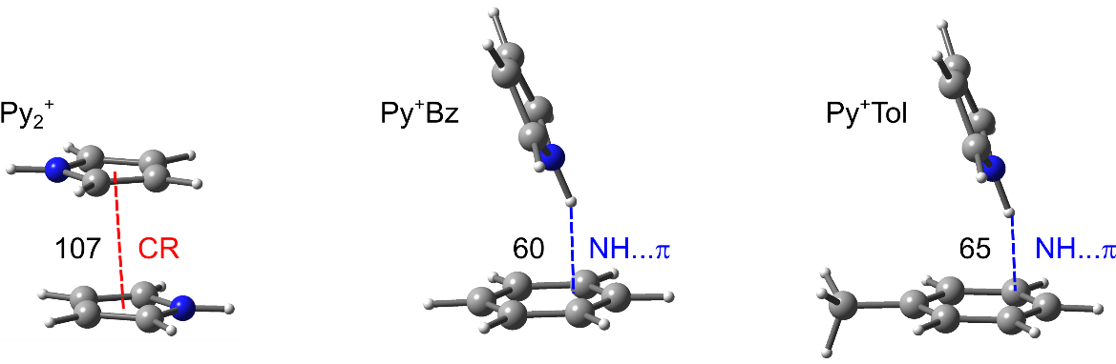

**Figure 1.** Structures of Py2+, Py+Bz, and Py+Tol with their binding energies, in kJ mol-1 (B3LYP-D3/aug-cc-pVTZ).

**References**

(1) Meyer, E. A.; Castellano, R. K.; Diederich, F. *Angew. Chem. Int. Ed.* 2003, *42*, 1210.

(2) Ma, J. C.; Dougherty, D. A. *Chem. Rev.* 1997, *97*, 1303.

(3) Ohashi, K.; Inokuchi, Y.; Nishi, N. *Chem. Phys. Lett.* 1996, *263*, 167.

(4) Chatterjee, K.; Matsumoto, Y.; Dopfer, O. *Angew. Chem. Int. Ed.* 2019, *58*, 3351.