**Spectroscopy Studies on Ices of Astrophysical Relevance**

**Christina M. Tonauer1,2,** Christian W. Huck3, Thomas Loerting1

1 *Institute of Physical Chemistry, University of Innsbruck, Austria*

2 *Deutsches Elektronen-Synchrotron DESY, 22607 Hamburg, Germany*

*3 Institute of Analytical Chemistry and Radiochemistry, University of Innsbruck, Austria*

To this date, 20 different crystalline and at least 3 distinct amorphous forms of water ice have been discovered. While only hexagonal ice occurs naturally on Earth’s surface, a variety of different ices is present in space, *e.g*, on icy moons, comets or interstellar dust grains. Water ice on these dust particles acts as a catalyst for the formation of complex organic molecules. Therefore, spectroscopic characterisation of water ices enables astrochemical exploration of icy objects.

However, there has been a hiatus of spectroscopic studies on ices after pioneering works from Whalley and co-workers in the 1960s, especially in the near-infrared (NIR) range (10000-4000 cm-1 /1-2.5 µm). The NIR range, however, is of high importance for the exploration of astronomical bodies, since NIR waves pierce through interstellar clouds, revealing objects lying behind.

Therefore, we here present [1-3] novel spectroscopic data of 11 crystalline and amorphous water ices in the near-infrared range (see Fig 1). The first overtone of the OH-stretching vibration is a powerful marker for density, porosity as well as hydrogen order, allowing for structural distinction of different ice structures present in space by telescopes such as the *James Webb Space Telescope* (*JWST*) or the *JUICE* mission.

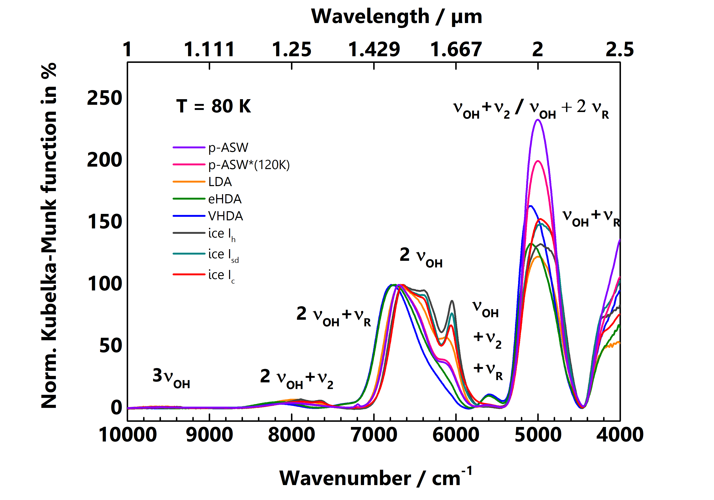

Figure 1: Near-infrared spectra of crystalline and amorphous water ices

**REFERENCES**

[1] **C. M. Tonauer**, Eva-Maria Köck, Tobias M. Gasser et al., J. Phys. Chem. A (2021), **125**, 1062.

[2] **C. M. Tonauer**, Eva-Maria Köck, Raphael Henn et al., Astrophys. J*.* (2024), **970**, 82.

[3] **C. M. Tonauer**, Eva-Maria Köck, Raphael Henn et al., PRL *(accepted June 2025)*